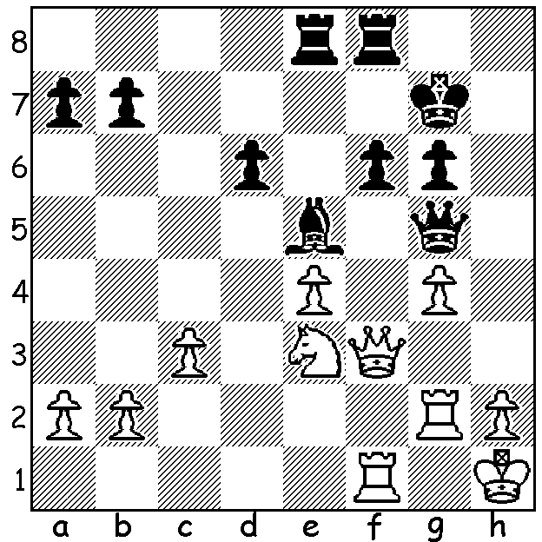
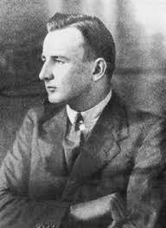
Stuart Milner-Barry (England)
v Jan Foltys (Czech.)
(Chess Olympiad 1939)
White to play and win material despite
Black's clever attempt to evade A young Sir Stuart Milner-Barry
loss on move 2: (4 moves): 1906- 1995

CHESS OLYMPIAD 1939
The 8th Chess Olympiad in Buenos Aires, Argentina, in 1939, the first time the event had been staged outside Europe, brought together a record number of countries, 27, mainly due to the interest in other Central and South American countries, although winners and runners-up from the previous Olympiad in Stockholm, USA and Hungary, both declined to send teams. After Preliminaries teams were divided into two groups with the top four teams from each of the four Preliminary groups qualifying for the A Finals with the rest playing in the B Finals. However the finals were due to start on September 1, the very date of the outbreak of World War II. After deliberations it was agreed to continue with only one team, England, deciding to leave, with three of their five players taking up positions with the code-breaking centre at Bletchley Park. When the finals were played six of the matches between enemy countries were unplayed and called 2-2 draws. Germany finished on top with 36/56 with Poland (35.5) second and Estonia (33.5) third. At the close of the event a host of players, many of them Jewish, decided not to return to their own countries, the most famous being Miguel Najdorf (Poland). Significantly all five members of the German team also stayed. This influx of players certainly ensured that Argentina would become a major force in world chess.

COMING TOURNAMENTS (see cawa.org.au)

GUFELD CUP (WA Grand Prix), Sunday 4 and Monday 5 April at Leeming Primary; contact: ellisd19@bigpond.com or 0439798607.

UWA BLITZ, Sunday 11 April; contact: aljen@upnaway.com or 043991223.

CARILLEY AUTUMN ALLEGRO, Sunday 18 April at Carilley Winery; contact: norbert.muller@iinet.net.au

JUNIOR CHESS CAMP, 8 & 9 April; contact: aljen@upnaway.com or 043991223

SOLUTION: White traps Black's queen with 1.Nf5+! Kf7 (1...gxf5 2.gxf5 wins queen immediately) 2.h4! Rh8 3.Rh2!! gxf5 4.hxg5 and wins; continued 4...Rxh2+ 5.Kg1 Reh8 6.Qxf5 Rxb2 (threat 6...Bh2+ 7.Kh1 Bf4+ 8.Kg1 Be3+ winning) 7.Qd7+ Kg6 8.Rxf6+! Bxf6 9.Qf5+ resigns (9...Kg7 10.Qxf6+ Kg8 11,g6)

