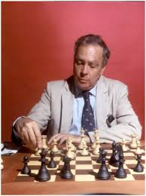
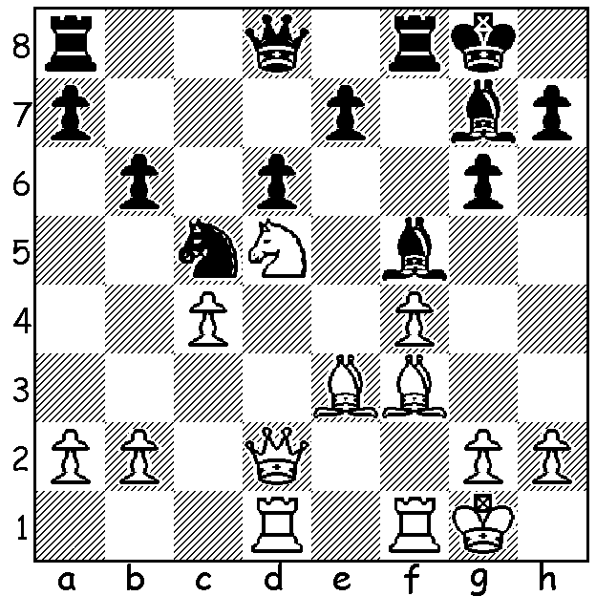

Oscar Panno v Pablo Ricardi 1992
White to play and win material
(4 moves):

OSCAR PANNO (1935-2021)
Last week I reported on the influx of talented players who remained in Argentina when World War II broke out in 1939 during the Chess Olympiad in Buenos Aires. However Oscar Panno was Argentinian born, the first top world player born in South America (Buenos Aires). He became the second World Junior Champion in 1953 and in that year he also won his first Argentinian championship. He became a Grandmaster aged twenty and is estimated to have been the 18th best player in the world in 1955. In that year he came 3rd of 21 players in the Gothenburg Interzonal, ahead of future world champions Tigran Petrosian and Boris Spassky. However his result in the 1956 Candidates was disappointing (8th of 10 players). He won a number of strong international events throughout his career and represented Argentina eleven times in Olympiads. He remained active in chess in his later years, finishing 3rd in the Bobby Fischer Memorial in 2008.

COMING TOURNAMENTS (see cawa.org.au)

GUFELD CUP (WA Grand Prix), tomorrow, Sunday 4 and Monday 5 April at Leeming Primary; contact ellisd19@bigpond.com or 0439798607.

JUNIOR CHESS CAMP, 8-9 April; contact aljen@upnaway.com or 0439912234.

UWA BLITZ, Sunday 11 April; contact aljen@upnaway.com or 0439912234.

CARILLEY AUTUMN ALLEGRO, Sunday 18 April at Carilley Winery; contact norbert.muller@iinet.net.au

SOLUTION: 1.Nxe7+! Qxe7 2.Bxa8 Rxa8 3.Qd5+ / 4.Qxa8.

