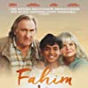
D Ellis v R.Fenn
West of England Jnr Ch 1958:
Find White's winning move:
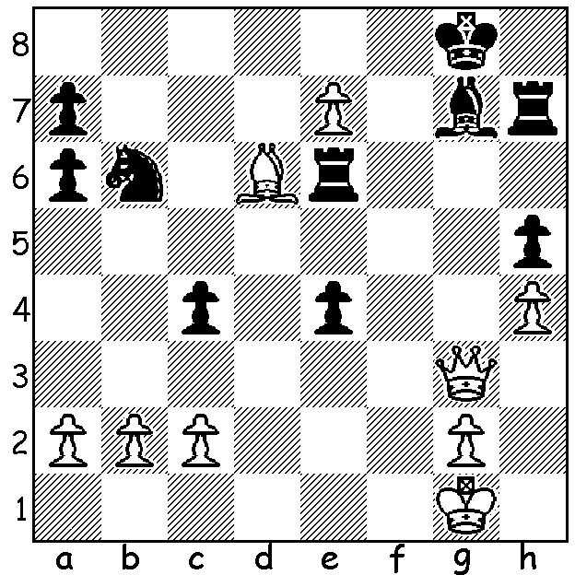

FAHIM, THE LITTLE CHESS PRINCE
Easter has been for much of my life a time for chess, attending the West of England Championships, firstly in junior events and later open events. In Western Australia CAWA has put on the Gufeld Cup each Easter commemorating the visit of Russian Grandmaster Eduard Gufeld to Perth in 1986. However this year I found an additional chess entertainment, watching the French film Fahim, the Little Chess Prince, depicting the struggles of a father and his young son from Bangladesh as illegal immigrants in France. The film naturally draws comparison with other screen chess stories such as Searching for Bobby Fischer (the story of a young Josh Waitzkin) and The Queens Gambit and I would rate Fahim as the best of the three with its human interest story, the story of the difficulties facing illegal immigrants in adapting to a new environment and language, poverty and homelessness, and the bureaucratic difficulties in seeking to be allowed to remain in France. While not having the many international film stars of Searching for Bobby Fischer, the film does have France's leading male actor Gerard Depardieu as a rather bad-tempered chess coach for a group of young students. I believe Fahim can be screened online, including Netflix, and I would certainly recommend watching this inspiring film.

COMING TOURNAMENTS (see cawa.org.au)
UWA BLITZ, Sunday 11 April; contact aljen@upnaway.com or 0439912234.
CARILLEY AUTUMN ALLEGRO, Sunday 18 April at Carilley Winery; contact norbert.muller@iinet.net.au

SOLUTION: 1.Qg6!! (deflection sacrifice - 1...Rxg6 2.e8=Q+ Bf8 3.Qxf8#).

