
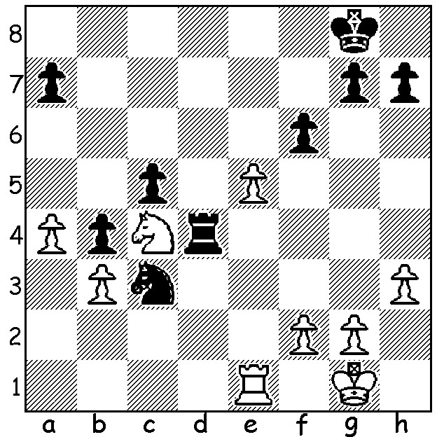


Anton Smirnov v Temur Kuybokarov 2018:
Black to play and win:

IMPORTANT TOURNAMENT WIN FOR TEMUR

With covid restrictions placing obstacles in many sports, chess can still function internationally on line. The first chess zonal held in Asia, Australia and Oceania with eight players was held last month with games played online but
with players permitted to use traditional boards and
sets to study before downloading their moves. Joint
leaders after the seven rounds were the two highest
rated players, Australians Temur Kuybokarov and
Anton Smirnov, who had drawn their encounter to
score 6.5/7. Their play-off was a very drawn out affair
with draws in their Rapidplay, a win to each in Fast
Rapid and again in Blitz. White in the Armageddon
game, West Australian Kubokarov had to win and this
he did after winning queen for two pieces and then
with seconds left swopping everything off to reach a
won king and pawn endgame.

While Temur is expected to qualify for the World Cup, Anton should also qualify as the Australian nomination.

The pair continued their rivalry at the annual Doerbel Cup in Canberra at Easter played under normal conditions with 54 players in the Premier event. Although again finishing with similar scores of 6.5/9 they were not among the prizewinners with young Australian Justin Tan and Englishman Fernandez Daniel Howard (7.5) the top performers followed by former Australian champion Bobby Cheng on 7.

SOLUTION: 1...Rxc4! 2.bxc4 b3 3.e6 (or 3.exf b2 4. Re8+ Kf7 5.fxg Kxg7) 3...Kf8 4.e7+ Ke8 and the rook is lost to b2/b1.

