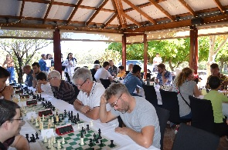
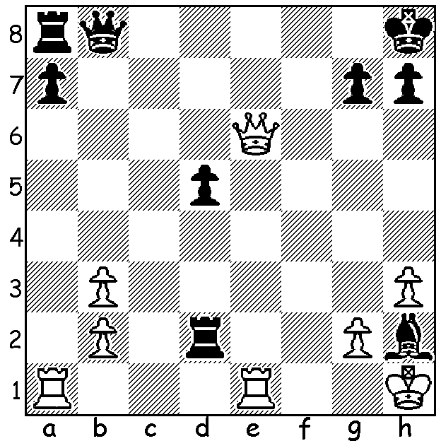

Thomas He - David Ellis (Carilley Allegro):
Black, a piece up, was confident but White has a surprise move:
Find that White move and Black's ingenious reply to avoid loss:

CARILLEY ESTATE ALLEGRO
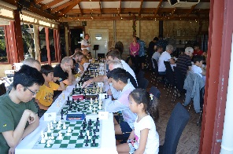
The Carilley Estate Allegro, the Autumn
component of the Four Seasons Allegros
played at popular wineries throughout the
year, was successful beyond expectations
with over 50 players attending. Thanks to
Norbert Muller, the creator of the concept
as well as organiser, his assistant on the day
Dylan Gough and the generosity of two
parties, the Carilley Estate for providing
the venue free of charge (and of course the
attractively priced and appetising lunch
menu), together with Mark Howard, the
new CAWA Treasurer for a substantial
donation to the prize fund. Winner was junior Rebo Fu with 6.5/7 followed by Tim Hare and Eduard Caledo (both 6/7). Other main prizewinners: Under 2000 - Dennis Holland (5.5), Derek
Elkington (5); Under 1800 - Herbert Cadag & Ned Tomic (5); Under 1500 - Francesco Dainese & Celine Ong (both 4); Under 1000 & Unrated - Ihsaan Barbare & Noah Taylor (both 4). There was a particularly good entry from juniors, both boys and girls, a large number of whom went away with prizes.

COMING EVENTS (see cawa.org.au)
ANZAC PUBLIC HOLIDAY RAPID, (6 rounds, 25min + 5sec), Monday 26 April at Leeming Primary 9.30 - 5.30. This event is OPEN TO NON CAWA MEMBERS. Contact Dylan Gough chessnut36@gmail.com or 0402747737.
WA OPEN CHAMPIONSHIP, 7 rounds, successive Sundays starting 16th May with a prize fund of over $3500.

SOLUTION: 1.Rxa7!! (if 1...R/Qxa7 2.Qe8+mates. Black played 1...h6? but lost his queen to 2.Rxa8 Qxa8 3.Qg6 (4.e8+). Black could defend with 1.Rxa7 Rd1!! 2.Rxa8 Rxe1+ 3.Qxe1 Qxa8 4.Kxh2 h6=.

