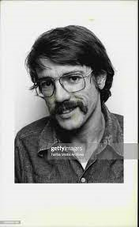
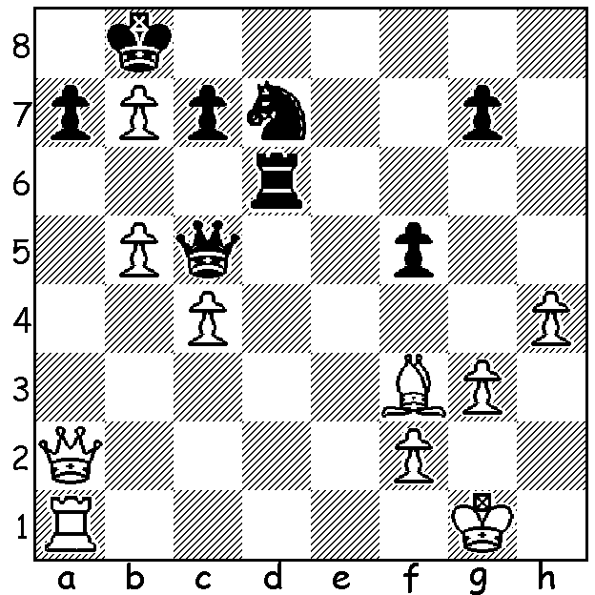

Terry Shaw v Mario Milazzo 1972:
Two subtle moves cause Black to resign:

TERREY SHAW, AUSTRALIAN CHESS IRONMAN
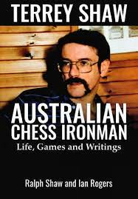
I recently received a copy of a new paperback chess publication,
Terrey Shaw, Australian Chess Ironman (Life, Games & Writings)
by his brother Ralph and Australian great GM Ian Rogers, now
an internationally respected commentator. As the back cover states,
Shaw acquired a reputation as a chess ironman, able to concentrate
just as well in the eighth hour of a game as the first. Besides the
fifty excellently annotated games of a talented Australian, the book
does much to show the personality of this fine human being. Readers
are given a number of reminiscences by his contemporaries as well
as a delightful humerous chapter by his first wife Philippa describing
life as a chess 'widow'. Terrey never succeeded in becoming
Australian champion - his best result being =1st in Perth 1978 before
losing the three-way playoff. He did however become an International
Master (IM) and represented Australia in nine consecutive Olympiads,
gaining two silver medals and achieving the best overall percentage
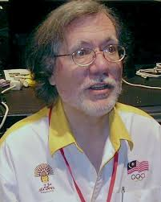
(61) of any Australian player competing in five or more Olympiads.
Sadly Terrey died in 1997, aged only 51. There appear to be two
minor errors in publication: an incorrect position in one game, picked
up and remedied by an insert; the dating of a game against Haydn
Barber in the Perth Australian Championship as 1975 instead of 1978.
However these do very little to distract from a well written and
attractively presented book with its many photographs and diagrams
and I would certainly recommend it for its portrayal of a dedicated
player before the era of professionalism in Australia (Shaw worked
as a programmer and later as a barrister). It is available from
Australian Chess Enterprises for $29.95.

Ian Rogers, co-author and main annotator

WA OPEN CHAMPIONSHIP: 7 rounds, successive Sundays starting May 16 with prize fund of over $3500 (see cawa.org.au).

SOLUTION: 1.b6! Qxb6, the deflection of the queen allowing 2.c5! opening up the a2-g8 diagonal. Black resigns (2...Qxc5 3.Qg8+ mating). A clever tactical thrust transferring the attack from a queenside frontal attack to the backrow on the far side.

