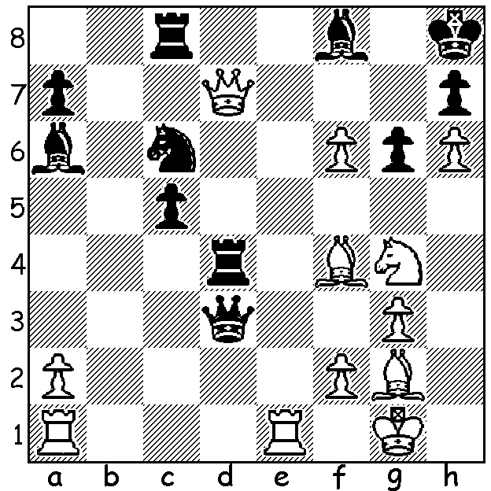
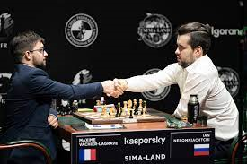
Ian Nepomniachtchi Nepomniachtchi (Rt) resigns vs Vachier-Lagrave
v Aggelos Sismanis 2000: in final round of Candidates
White wins (3 moves)

NEPO TO CHALLENGE MAGNUS
The FIDE Candidates Tournament, which began in March last year when Covid 9 was beginning to become a worldwide danger and then halted halfway through, resumed last month. It was won with a round to spare by Russian Ian Nepomniachtchi with a score of 8.5/14. Second was Maxime Vachier-Lagrave (8), who defeated Nepo in the final round, followed by Anish Giri and Fabiano Caruana (both 7.5), Ding Liren and Alexander Grischuk (both 7), Kirill Alekseenko (5.5) and Wang Hao (5). Nepo will now have the opportunity to take the world title from Magnus Carlsen when they meet in a 14 game match in Dubai between November 24 and December 16 during the rescheduled Expo 2020. Carlsen won the title in 2013 against Vishy Anand and successfully defended his title against Anand in 2014, Sergey Karjakin in 2016 and Fabiano Caruana in 2018.

COMING EVENTS (see cawa.org.au)
WA OPEN CHAMPIONSHIP, 7 rounds, successive Sundays starting 16th May with a prize fund of over $3500. Closing date for entry is May 12th.

CHESS AT UWA
The 2021 UWA Blitz (34 players) was played on 11th April and won by Tristan Boyd. Herbert Cadag was first Under 1500 and Ishaan Barbara and James Ryan joint first Under 1200.

SOLUTION: 1.Qg7+!! Bxg6 2.hxg6+ Kg8 3.Nh6#.

