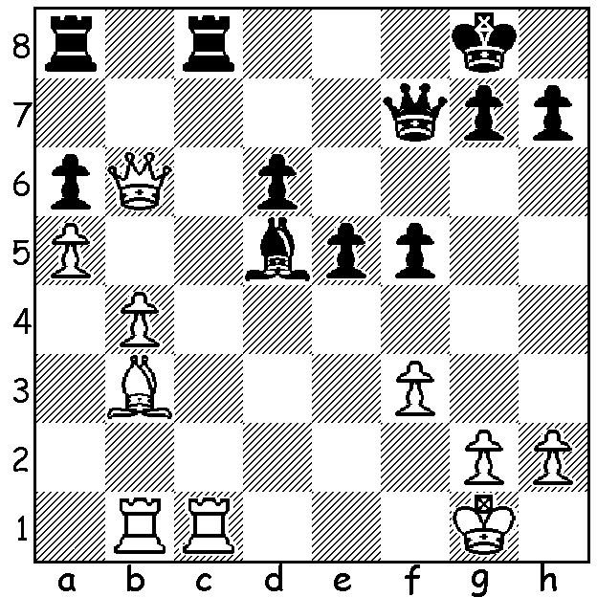
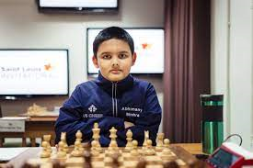
Sergey Karjakin v Alexandra Kosteniuk: Abhimanya Mishra
White finishes a piece up after 7 moves
(moves 1 & 5 are the !!):

Race to be youngest GM
Russian Sergey Karjakin became a Grandmaster in 2002 at the age of 12yrs 7mths but his record as the world's youngest GM could well be broken in the very near future (current world champion Magnus Carlsen became a GM aged 13yrs 4mths). Abhimanya Mishra (DOB 5 Feb 2009), from New Jersey, USA, became the youngest ever International Master at the age of ten and has already achieved two of the three required GM norms in tournaments. Mishra, who learnt the game at the age of two and a half, has until 5 September to score his third tournament norm as well as improve his rating by 24 points. This may entail his needing a score of 7/9. In his last tournament, where he scored 8/9, well ahead of the rest of the field, his performance rating was 2739, the level of the rop 20 GMs in the world.
Earlier this year I wrote articles of a number of late teenage and early twenties players who might have aspirations to be world champion. However they may find they will be overshadowed by players at present still at primary school.

2021 WA Open Championship
The WA Open Championship (50 entries) began last Sunday with FM Patrick Gong the top seed. Other leading players include two former WA champions, Tim Hare and Craig Kinsman, teenagers Jamie Laubbacher and Rebo Fu, as well as Edward Calado and WFM Kathryn Hardegen. In Rd 1, where the top half play the bottom half, the only surprise was the win by Mark Howard, ranked 33, against Dominador Andador (ranked 8).

SOLUTION: 1.Qxa6!! Rxc1+ 2.Rxc1 Rxa6 3.Rc8+ Qe8! (3...Qf8? 4.Bxd5+ Kh8 5.Rxf8#) 4.Rxe8+ Kf7 5.Ra8!! (5.Bxd5+ would also win but this is more decisive and spectacular) Black resigns (5...Rxa8 6.Bxd5+ Kf8 7.Bxa8). This game was played when Karjakin was only 13.

