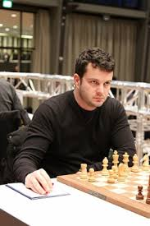
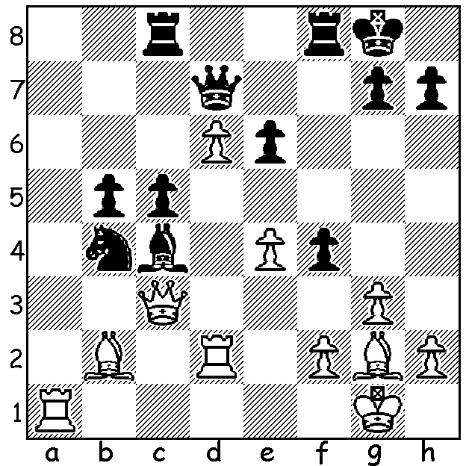
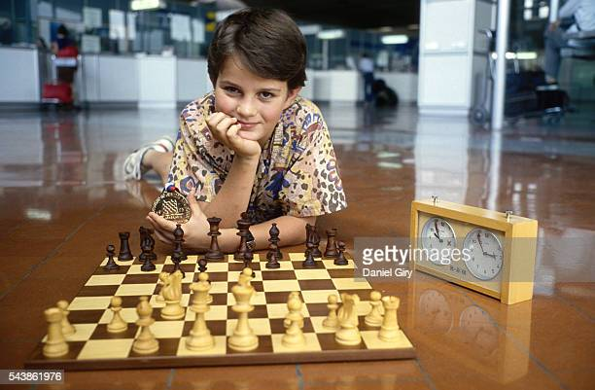
Etienne Bacrot v Joel Lautier 2002:
White, the exchange and a pawn down,
wins quickly (2 moves)

Chess Prodigies
More on young players around the world; firstly news
that a ten year old Nigerian refugee, Tani Adewumi, has
become a national master (NMUSA), awarded to players
rated above 2200. Secondly, Marc Andrian Maurizza at
14yrs 5days has become the youngest French player to
become a grandmaster (GM). He beats the record of
Etienne Bacrot who became a GM in 1997 at the age of Two pictures of Etienne Bacrot
14yrs 2mths, at the time a world record.

2021 WA Open Championship
No surprises in Rd 2 of the WA Championship which means Rd 3 will bring the leading players, all on 2/2, up against each other - 2020 champion FM Patrick Gong plays 1984 joint winner Craig Kinsman, 2010 champion Tim Hare plays Valero Falassca, 2020 WA Womens Champion WFM Kathryn Hardegen plays 2020 Under 16 champion Jamie Labbacher, David King plays 2020 WA Junior Champion Rebo Fu, Edward Calado plays Walter Stassen and WA Under 14 champion Oscar Gao plays Derek Elkington (1.5). Games start at 1pm at Leeming Primary and spectators are welcome.

SOLUTION: 1.Ra7! Qxa7 (1...Nd5 2.Rxd5!) 2.d7 & Black has no defence against the queen & bishop battery (2...Rf7 3.dxc8=Q).

