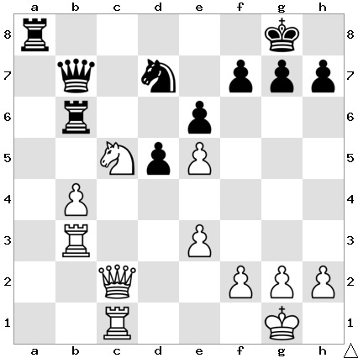

Carlsen vs So (Crypto Cup 2021):
Black to play and win (5 moves):

ANOTHER TOURNAMENT WIN TO MAGNUS
The recently completed FTX Crypto Cup offered a record US$320,000 for an online event. It began with 16 of the world's top players an all-play-all with the eight players going into a knockout. Of particular interest was the Magnus Carlsen game against Ian Nepomniachtchi with Magnus' world championship challenger managing to gain a draw. There was a possibility of the two meeting in the final but while Carlsen defeated Temour Radjabov Nepo lost his semi-final match to Wesley So. So had twice defeated Carlsen previously in finals but this time the world champion came out on top. After six games with each player winning two games and drawing two the match was concluded with a Carlsen win in their seventh game, an Armageddon, when a draw would have given So (who had the Black pieces) victory.

WA CHAMPIONSHIP
Round 3 brought involved a number of top player clashes.Results: Patrick Gong defeated Craig
Kinsman, Kathryn Hardegen drew with Jamie Labbacher, Tim Hare defeated Valerio Felasca, David King lost to Rebo Fu, Edward Calado lost to Walter Stassen, Oscar Gao defeated Derek Elkington.
Round 4 will be played tomorrow at Leeming Primary starting at 1.00pm. Spectators welcome.

SOLUTION: 1...Nxc5 2.Qxc5 Rc6!! (if 3.Qxc6 Qxc6 4.Rxc6 Ra1+ 5.Rc1 Rxc1#. Carlsen gave up his queen for rook but soon lost). Even the world champion can fall foul of back row mating combos!

