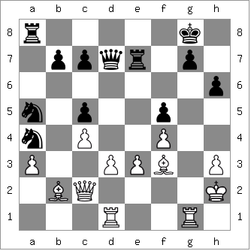
Viktor Korchnoi v Bertus Enklaar 1976
White to play and win:

CHESS THE MUSICAL

Chess, the Musical, with lyrics by Tim Rice and music by Abba's Benny Andersson and Bjorn Ulvaeus which includes the hit 'One Night in Bankok', concluded its Australian tour in Brisbane this week. The plot centres on two world championship matches, American vs Russian then the successful Russian, now a defector to the USA, against a new Russian challenger. The chess plot is complicated by a love triangle as well as the pervading background of the Cold War.
It is clearly inspired by the Spassky vs Fischer match, with the American taking the title from the
Russian, and the Karpov vs Korchnoi match where the Russian Karpov held off a strong challenge from the stateless ex-Russian Korchnoi. The script even included the yoghurt controversy when
Korchnoi's team claimed the delivery of different flavours was giving Karpov signals.

I went to see Chess last week at the Perth Concert Hall where the show was played out on a
giant chess board with a 25 piece orchestra and choir. Reviews have been mixed and although
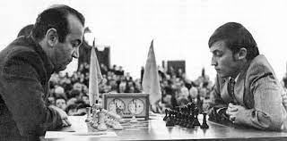
they praise the singing the Perth production had a serious problem with the sound production making it almost impossible to follow the story. I asked a number of patrons after the show and they were all of the same opinion. I've seen Chess a number of times, twice at PCH, once at WAAPA and the first over 20 years ago at Playlovers, a full stage production, which was for me the best of the four.

SOLUTION: the obvious move
to preserve the attacked bishop is
1.Be5 but far better is 1.Bf6! and
then if 1...Rf7 2.Bd5 wins.

Korchnoi v Karpov (Wld Ch 1978)

