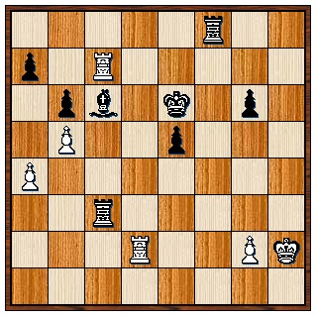
Fabiano Caruana v Shakhtiyar Mamedyarov, 2021
Simplification is a common way of turning a small material advantage into a won position. White, a pawn down, threatens bxc6 with counterplay. However Black has a simplifying combination to reach an easily winning position (4/5 moves):

SUPERBET ROMANIA
The 2021 Grand Chess Tour kicked off with a classic chess tournamentat the Sheraton, Bucharest, with eight of the world's leading players joining two top Romanians in a ten player round robin. Winner was Shakhriyar Mamedyarov with 6/9 (+3 =6) with three players, Wesley So, Levon Aronian and Alexander Grischuk equal second with 5/9. Other scores: Anish Giri, Teimour Radjabov (who drew all 9 games) 4.5, Bogdan-Daniel Deac, Maxine Vachier-Lagrave 4, Constantin Lipelescu 3.5. Azerbaijani Mamedyarov, who earned US$90,000 for his efforts, is a former World Junior Champion (2003 and 2005) and World Rapidplay Champion (2013). His personal best rating of 2820, makes him the sixth highest rated player of all time.

WA CHAMPIONSHIP
Leading results from Rd 5: Patrick Gong - Rebo Fu 1-0, David King - Jamie Laubbacher 0-1, Kathryn Hardegen - Craig Kinsman 1-0, Oscar Gao - Valerio Falasca 0-1, Tim Hare - Walter Stassen =. Round 6 top pairings: Laubbacher - Gong, Fu - K Hardegen, Falasca - Stassen, Andador Dominador - Hare. To be played at Leeming Primary tomorrow.

SOLUTION: 1...Rh8+ 2.Kg1 Rh1+! (deflection) 3.Kxh1 (3.Kf2 Rhc1) 3...Bxg2+! (discovered attack) 4.Rxg2 Rxc7 5.Rxg6+ Kd5 and Black will cut off White's king with ...Rf7 and advance his e pawn to victory.

