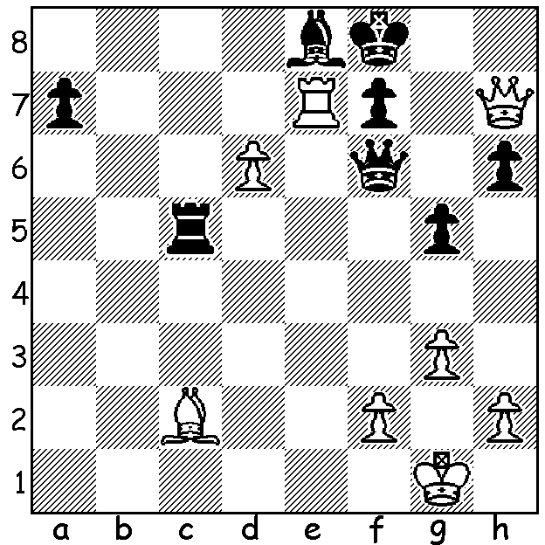
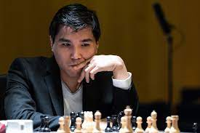
Wesley So v Richard Rapport Wesley So
(Paris Rapid June 2021):
White to play and win:

PARIS RAPID & BLITZ
Earlier this week Filipino born US GM Wesley So won the Paris Rapid & Blitz event, part of the 2021 Grand Chess Tour, coming first in both sections with 6/9 in the Rapid and 12.5/18 in the Blitz for a combined total of 24.5/36 (Rapid scores doubled). Second was Russian Ian Nepomniachtchi (21.5), who faces defending champion Magnus Carlsen in November for the world title. Other players involved (in order of finishing) were Maxime Vachier-Lagrave, Alireza Firoujia, Levon Aronian, Richard Rapport, Peter Svidler, Fabiano Caruana, Etienne Bacrot (only Rapid) + Vladimir Kramnik (only Blitz), Teimour Radjabov.

WA CHAMPIONSHIP
Round 6 saw a new leader emerging in the 2021 WA Chmapionship with schoolboy Jamie Laubbacher wresting the lead from his opponent the top-ranked FM (Fide Master) Patrick Gong. Other leading results: Rebo Fu - Kathryn Hardegen =, Valerio Falasca - Walter Stassen 0-1, Andador Dominador - Tim Hare 0-1. The final will be played at Leeming Primary 1pm tomorrow.
Spectators welcome.

SOLUTION: 1.Bg6!and if 1...fxg6 2.Qxh6+ Kg8 3.Rxe8+ or 1..Qxg6 2.Qh8+ Qg8 3.Rxe8+! or 1...Qxd6 2.Rxf7+! Bxf7 3.Qxf7# (a pleasing interference or obstruction sacrifice).

