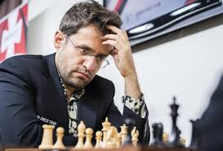
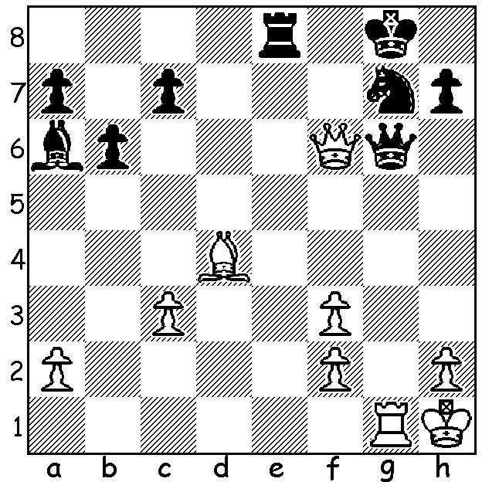
Levon Aronian
Alireza Firouzja vs Levon Aronian
(Goldmoney Asian Rapid 2021)
Black to play and win (5 moves):

WA CHAMPIONSHIP

After beating the top-ranked player and defending champion, FM (Fide Master) Patrick Gong, in Rd 6, high school student Jamie Laubbacher defeated Walter Stassen in the final round to win the tournament with 6.5/7. Gong defeated Kathryn Hardegen to take second place with 6/7 while another junior Rebo Fu defeated a former champion Tim Hare to finish 3rd on 5.5. It was pleasing to see an entry of 50 players and strong performances from many juniors. Three females played with all three doing well. Kathryn Hardegen scored 5 to become once again Womens Champion while high school student and joint Girls Champion Celine Ong (4) shared the top Under 1600 spot and Primary school student and the other joint Girls Champion, Emily Zhang, scored 2.5 from her final three games. Four players, Walter Stassen, junior Kundan Dharmapuri, Derek Elkington and Tjermin Gunawan with 4/7 will play off for the Reserves title (Under 2000).

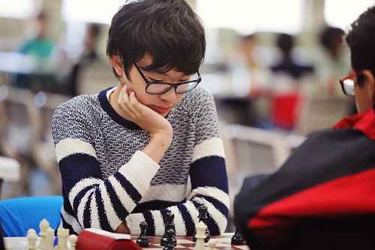
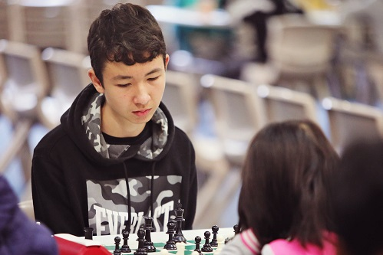
Jamie Laubbacher Rebo Fu

GOLD MONEY ASIAN RAPID
The Goldmoney Asian Rapid is a 16 player round robin with the top eight players going into knockout mini matches. Four Indian and two Chinese players, Ding Liren and Hou Yifan, joined a number of regulars in the World Tour event. Winner of the preliminary was Armenian Levon Aronian, the only undefeated player, scoring 10.5/15.

CAWA EVENTS JULY: South of River Chess Festival starting Wed 7th (9 weeks). WA Blitz Championship 11th. WA Junior Championships 12th to 15th. SW Open 31st & 1st August. Check details at cawa.org.au (calendar)

SOLUTION: White's attack has failed but he is still in the game after 1...Qxf6 2.Bxf6 Kf7 3.Bxg7. However Black wins quickly with 1...Qxg1+! 2.Kxg1 Re1+ 3.Kg2 Bf1+ 4.Kg3 (4.Kg1/h1 Bh3#) 4...Nh5+ forking king and queen.

