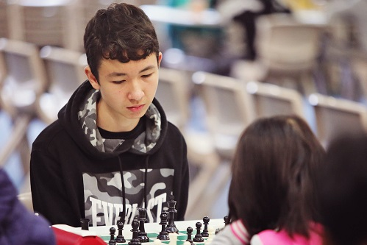
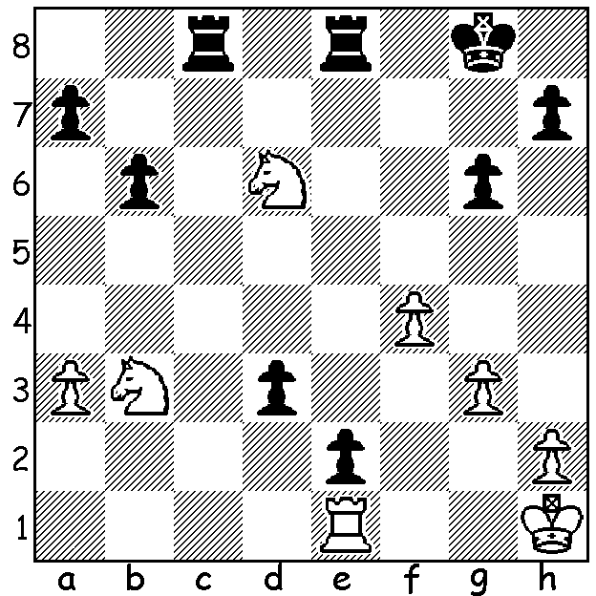

Tim Hare v Jamie Laubbacher 2020 Jamie Laubbacher
How does Black use his united passed
pawns to gain a winning position?
(The first move is spectacular - 6 moves)?

YOUNGEST EVER WA CHESS CHAMPION
As reported a fortnight ago, the WA Chess Championship was won by high school student Jamie Laubbacher who finished with a score of 6.5/7 after defeating defending champion FM Patrick Gong in the penultimate round. Jamie, a student at Perth Modern, at 16 becomes the youngest player ever to achieve this feat. What makes this achievement even more amazing is the fact Jamie only took up the game about three years ago and, although encouraged by his father to take up the game, is virtually self-taught, gleaning information through print and web sites as well as regular tournament play. He is already WA Rapidplay champion and has a chance tomorrow to add the WA Blitz Championship to a rapidly increasing list of tournament successes. (This week's Sunday Times had an excellent report complete with photo.)

GOLD MONEY ASIAN RAPID
After topping the the Goldmoney Asian Rapid 16 player round robin and being the only undefeated player, Levon Aronian went on to win the event, winning his three knock-out mini matches. His succes included victory over world champion Magnus Carlsen in the semi-final.

CAWA EVENTS JULY:
The WA Blitz Championship takes place tomorrow at Leeming Primary, 1-4pm. Entries andrewhardegen@iinet.net.au or at venue by 12.30 Sunday.
WA Junior Championships 12th to 15th. SW Open 31st & 1st August.
Check details at cawa.org.au (calendar)

SOLUTION: 1...Rc1!! 2.Rxc1 d2!! 3.Nxd2 e1=Q+ 4.Rxe1 Rxe1+ 5.Kg2 Re2+ / 6...Rxd2- sensational! (1...d2 would be a mistake - 2.Nxd2 Rc1 3.Nf3 but 2...e1=Q+ 3.Rxe1 Rxe1+ 4.Kg2 d2! would also win).

