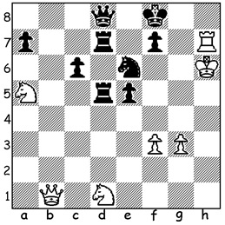
White to play and win (12 moves):
I recently saw this position from chess-
teacher.com and decided to share it with you
today. It claimed that world champion Magnus
Carlsen might be unable to find a win for White
here. It's almost cerainly a composed problem
but a brilliant one. White is material down and
his king is precariouly placed, trapped on the h
file. Therefore drastic measures are needed to
create an attack against Black's seemingly more
secure king. White's first move is the very natural 1.Rh8+ and after 1...Ke7 can play 2.Rxd8.
However after 2...Nxd8 both knights are under
attack and if 3.Qb4+ c5 or 3.Ne3 Rxa5! 4.Qb4+
Rd6+. So White ignores the queen capture and
plays 2.Nxc6+ and after 2...Kf6 again finds the queen capture loses (3.Nxd8 Rxd1 or 3.Rxd8 Rxd8! 4.Nxd8 Rxd8 5.Qh7 6.Rxd1). Now comes the first of the spectacular moves, 3.Rg8!!! (threatening 4.Rg6+! fxg6 5.Qxg6#) followed by 3...Rxg8 4.Qf5+!! Kxf5 5.Ne7+!! (a brilliant obstruction sacrifice cutting off a king escape to e7). White is Q, 2R & p down but his to-now dormant knight springs into action, 6.Ne3+ Kf6 7.Nxd5+ Kf5 8.Nxe7+ Kf6 9.Nxg8+ Kf5 10.Ne7+ Kf6 11.Nd5+! Kf5 12.g4#. What an amazing combination with an obstruction sacrifice followed by two deflection sacrifices and every piece (even the king) contributing to the win!

A TALE OF TWO EX-CHAMPIONS
At the recently completed 10 player Croatia Grand Tour Rapidplay & Blitz played in Zagreb, Gary Kasparov made a rare chess appearance competing in the Blitz. Not a happy time for the ex-world champion, now aged 58, who finished with only 2.5/18, losing a number of games on time. Contrast this with Vishy Anand, aged 51, another ex-world champion, who scored 13/18, equal first with Maxime Vachier-Lagrave, the overall winner (Rapid & Blitz combined).

Vishy Anand Gary Kasparov Maxime Vachier-Lagrave
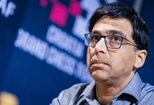
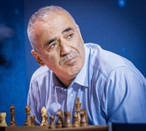


THE SOUTH WEST OPEN (WA GP) is planned for Sat 31 July & Sun 1 August in Burekup near Bunbury. See cawa.org.au and support the event.

