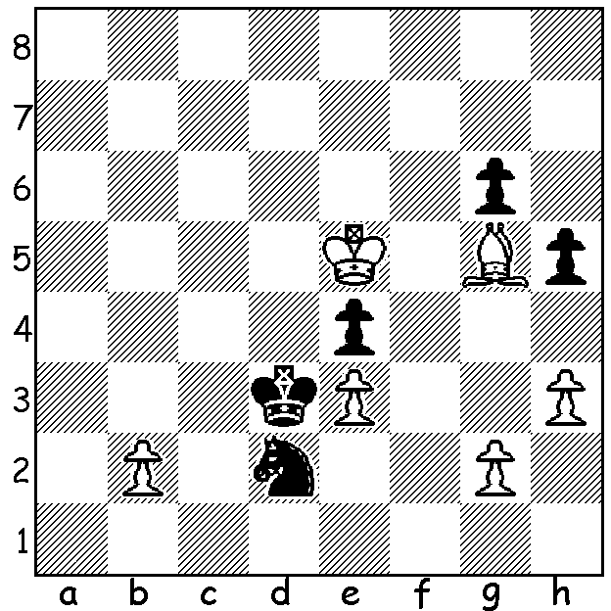
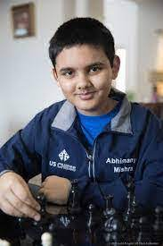
Leon Mendonca v Abhimanyu Mishra 2021
Black to play:White, a pawn up and ready to
capture Black's g & h pawns, is given a shock
which leads to a draw or win to Black: Abhimanyu Mishra

YOUNGEST EVER GRANDMASTER
Abhimanyu Mishra, at 12 years 4 months old, is now the youngest GM ever, breaking the record of Sergey Karjakin, who was 12 years 7 months old when he gained the title in 2002. Mishra grew up in New Jersey and has been playing since he was seven. He had been held up in his quest for a considerable time due to covid restrictions but was able to play in a series of fortnightly tournaments in Budapest which were created to further the careers and improve the ratings of aspiring players.
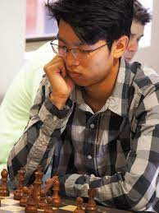
WA BLITZ CHAMPIONSHIP
The WA Blitz Championship took place earlier
this month and resulted in a victory to FM Patrick
Gong with an almost perfect score of 10.5/11. He
was followed by junior Rebo Fu (9) and ex-state
champion Tim Hare (8). Other outstanding results
were obtained by Herbert Cadag (4th= overall and
winner of Under 1700 prize with 7) and Under 1500
joint winners Celine Ong and Virudhagiri
Muruganandam (5.5). Junior Jamie Laubbacher, who
earlier had won both the 2021 WA Championship and
the 2021 WA Rapidplay Championship, had a
disappointing tournament scoring 6. Patrick Gong

SOLUTION: 1...Nf3+!! White can decline the sacrifice with 2.Kf4 which leads to draw after 2...Nxg5 3.Kxg5 Kxe3 4.b4 Kf2 5.b5 e3 6.b6 e2 7.b7 e1Q 8.b8Q = while acceptance (which White played) loses - 2.gxf3 exf3 3.Bh4 g5! 4.Bf2 Ke2 5.b4 Kxf2 6.b5 Kxe3 7.b6 f2 8.b7 f1Q b8Q Qf4+.

