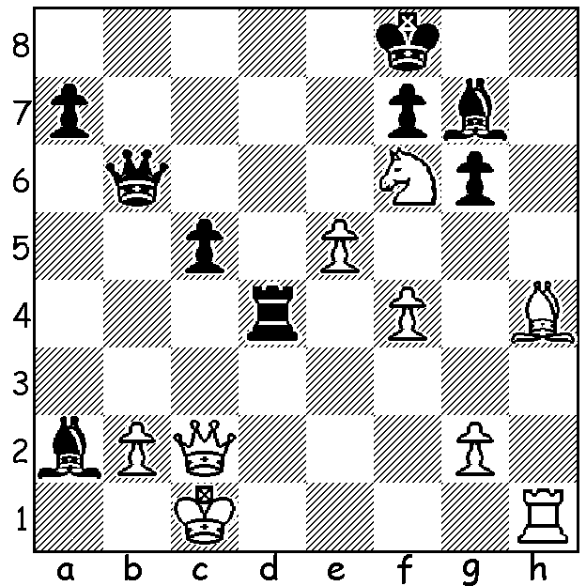
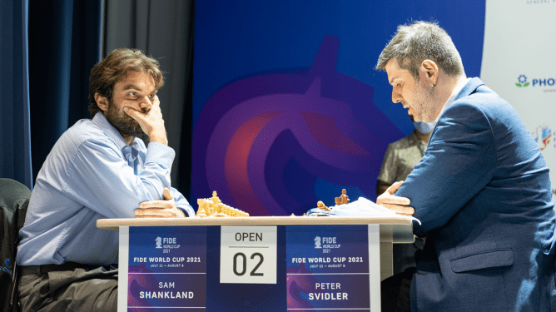
Sam Shankland v Peter Svidler Shankland v Svidler
(World Cup July 2021)
White to play and win

SLEEP and INSOMNIA
Some weeks ago I came across these words in the West from bridge columnist Nigel Dutton: 'A few players have suggested to me that one of the reasons they are not keen on evening bridge is the difficulty of unwinding and relaxing the brain sufficiently to get to sleep.'
Problems with sleep may be even more very common among chess players. Such ideas are succinctly expressed by Arjun Viswanathan who writes, '... any game that we won/lose (I would suggest especially lose) always keeps on running in mind (sic) and it's always difficult to get rid of such thoughts. So when you go to bed and the last thing you did was playing chess, then the night is going to be difficult.'
Now if, like me, you are naturally not a good sleeper you might agree with the thoughts of Des Catolos: 'I could not think of a more tortuous situation than playing a standard (with increment to make things even worse) or classical game if you are hardly getting enough sleep for days.'
Long tournaments with daily games, such as in Australian Championships, were particularly difficult although now, with increasing age, I can, like Nigel Dutton, say it's been years since I have been kept awake at night thinking of the evening's game.

CHESS and the ARTS

Did you know we have a talented artist in
the WA chess community? Fred Maris, who
has been president of both the Midland and
Perth (Woodvale) clubs, has an exhibition of
his paintings at Guildford Potters Gallery, 22
Meadow St., Guildford which runs until
August 23rd. (see additional pictures below)

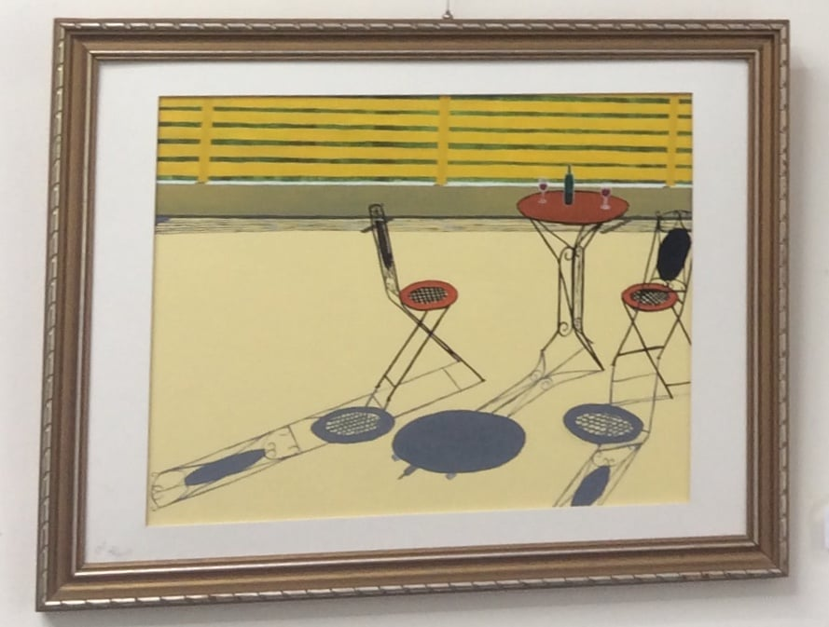


SOLUTION: 1.Bf2!(ignoring the threat of 1...Rc4 - 2.Nd7+) 1...Bxf6 (there's nothing better) 2.exf6 Qxf6 3.Qxc5+ Rd6 (3...Qd6 4.Bxd4) 4.Qc8+ resigns (4...Rd8 5.Rh8+! Qxh8 6.Qxd8+ Kg7 7.Bd4+ or 4...Ke7 5.Bh4 Rc6+? 6.Qxc6).

