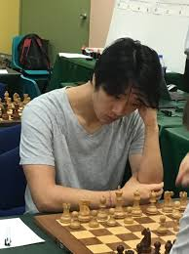
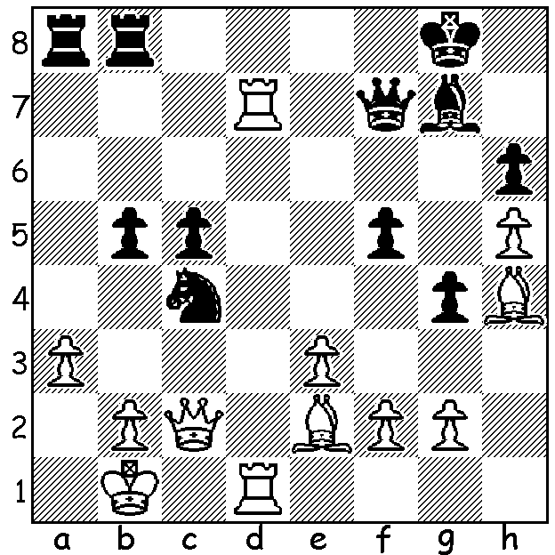

Christopher Wallis v Bobby Cheng 2018
Black to play and win Bobby Cheng

CHESS WORLD CUP
The Chess World Cup has been played since 2000 when Viswanathan Anand was the winner. Since 2005 it has become a biannual knock-out event of 128 players with one to three players able to qualify for the World Championship Candidates. This year the event expanded to 206 players with 50 seeded players automatically going into Rd 2. Each round consists of two classical games over two days with tie-breaks, if needed, on day three. Tie breaks consist of two 25min + 10sec rapidplay and then, if needed, two 5min + 3sec blitz games, followed, if needed, by an Armageddon game (White 5min, Black 4min) which White must win to progress. Australia had one participant, Bobby Cheng who was World Under 12 champion in 2009. Cheng won his first round and in Rd 2 was due to play a top player Levon Aronian who unfortunatly withdrew because of possible covid infection. Cheng was then eliminated in Rd 3, 0.5-1.5. At time of writing the final is still to be played with world champion Magnus Carlsen playing Jan-Krzysztof Duda and Vladimir Fedosev playing Sergey Karjakin in the semis. More next week.

FOUR SEASONS ALLEGRO
Get along to the Winter Allegro on Sunday 15th August at The Abbey at Chesters in the Swan Valley. This is the third of the Four Seasons events which have seen entries exceeding 50. Enrol by Friday 13th as late entries will not be accepted. Details cawa.org.au

SOLUTION: 1...Nxa3+!! 2.bxa3 Rxa3 3.Rxf7 Ra1# or 3.Kc1 Ra1+ 4.Kd2 Qxd7+ or 3.Qxc5 Qb3+ 4.Kc1 Qb2#.

