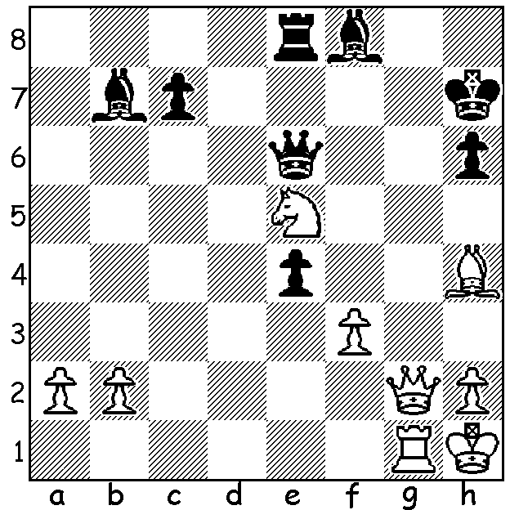
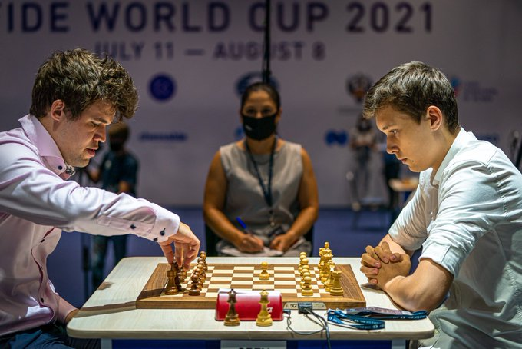
Jan-Krzysztof Duda v Carlsen v Duda (World Cup 2021)
Levan Pantsulaia 2017
White to play and win

CHESS WORLD CUP, Semis & Final
The semifinals of the 2021 World Cup saw world champion Magnus Carlsen opposed to 23 year old Jan-Krzysztof Duda who last year ended Carlsen's 125 unbeaten run, while Sergey Karjakin faced Vladimir Fedoseev. In the Duda-Carlsen match, after three fairly uneventful draws, Duda overcame Carlsen in the second Rapidplay game in a good v bad bishop endgame (a bad bishop has most or all of the pawns blocked on the same colour as the bishop, restricting its mobility and unable to attack the opposing pawns). In the other semi Karjakin went through to the final with a straight 2-0 victory. In the first game of the final Karjakin (White) grabbed the loose a pawn on move 13 allowing a perpetual attack on his queen. In the second Duda won a pawn in the endgame bringing a resignation from Karjakin and triumph for Duda 1.5-0.5. The young Polish GM, who didn't lose a game during the event, will probably move into the top world 10 players and both he and Karjakin qualify for the next Candidates tournament to find a challenger to the world champion, be it Carlsen or Nepomniachtchi. In the play-off for third Carlsen, who has never won the World Cup, threw off the disappointment of his semifinal loss to play two exquisite games, each involving positional sacrifice of rook for bishop, to win 2-0. (Correction of last week's column: I stated the World Cup is played biannually; I should have said biennially, every two years.)

FOUR SEASONS ALLEGRO
Come along to the Winter Allegro this Sunday 15th August at The Abbey at Chesters in the Swan Valley. This is the third of the Four Seasons events which have seen entries exceeding 50. Entry cut-off extended so contact norbert.muller@iinet.net.au or 0419950619.

SOLUTION: 1.Bf6! (deflection and obstruction sacrifice taking advantage of Black's overworked queen defending g6 & g8) 1...Qxf6 2.Qg8#.

