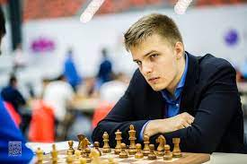
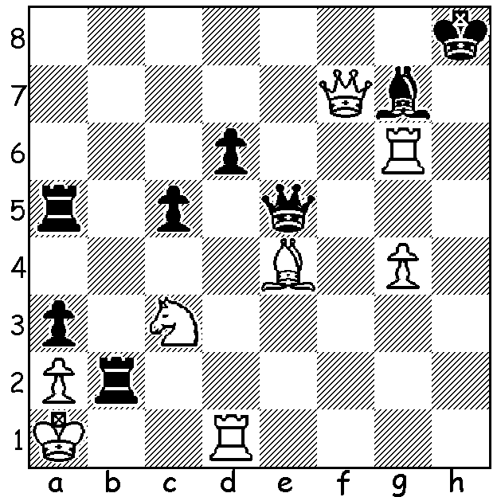
Shakhriyar Mamedyarov vs Richard Rapport Richard Rapport
(St Louis Blitz 2021): Black, a piece down and
threatened with mate by 1.Rh6+ and 1.Rh1+ pulls
off a spectacular mate:

NAKAMURA WINS ST LOUIS RAPIDPLAY & BLITZ
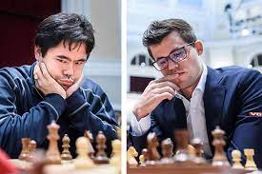
Hikaru Nakamura had one of his greatest successes with victory at the annual St Louis Rapidplay and Blitz (part of the Grand Chess Tour), going through the tournament undefeated. Because of virus restrictions the tournament was unable to attract a number of foreign players but top Americans, Fabiano Caruana, Nakamura, Wesley So, Sam Shankland, Leinier Dominguez and Jeffrey Xiong were joined by Shakhriyar Mamedyarov (Azerbaijan), Peter Svidler (Russia), Richard Rapport (Hungary) and Le Quang Liem (Vietnam) with Xiong the lowest rated player on 2690. In the Rapidplay Nakamura finished with 7 wins and 4 draws, scoring 12/18, and 6 wins and 12 draws in the Blitz (12/18). So dominant was Nakamura that he had won the tournament with 3 Blitz games to play. However his success was
tempered by losing his world number 1 spot in
Rapid and Blitz to world champion Magnus
Carlsen who tweeted, 'Congrats to world #2
rated rapid and blitz player GM Hikaru for
winning STL RapidBlitz with a dominating
unbeaten performance!' While Nakamura is
Number 2 in Rapid and Blitz, he is considerably
lower in Classic, 19th.

Nakamura & Carlsen

SOLUTION: 1...Rb1+!! (clearance sacrifice) 2.Kxb1 Rb5+ (deflection sacrifice) 3.Kc1
(3.Nxb5 Qb2#) 3...Qxc3+ 4.Bc2 Rb1+! (deflection sacrfice) White resigns (5.Kxb1 Qb2#).
And this was played with a Blitz time control of 5min + 2sec increment per move!

