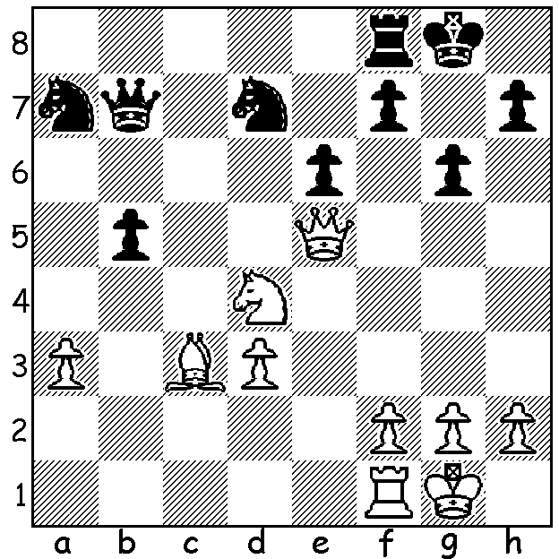
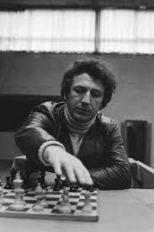

Evgeny Sveshnikov vs Ruslan Scherbakov
(USSR Ch 1991): White to play and win: Evgeny Sveshnikov

RECENT OPEN EVENTS IN WA
Excluding the WA Championship tournaments in Classic, Rapidplay and Blitz and also Junior events, most CAWA tournaments enable participants to strive for overall success in the WA Grand Prix, weekend events spread over the year. 2021 has seen Rapidplay and Blitz events included together with the 60 minute six round events for the first time.

One particularly successful innovation has been the introduction of the Four Seasons Allegro tournaments, each a one day Rapidplay event. The idea came from Norbert Muller who has also been Director of Play for these events held on Sundays at leading WA wineries. Norbert has been a devoted organiser of Chess for over 40 years both on the club and state level, with the setting up the Kingsley Junior Club and the holding of a number of positions within the Association among his many contributions to the game in this state.

As older volunteers retire or lessen their involvement in the game, others appear to take their place. One such relative newcomer to organising events is Ian McAteer who has become the co-ordinator of the WA GP. Ian has set up and run the annual South of the River Chess Festival at the Blue Gum Community Centre, Brentwood, with Classic, Rapidplay and Blitz events, and this year he also resurrected the South West Open, held for the first time in Burekup near Bunbury.
Results from these events next week.

SOLUTION : 1.Qg7+!! Kxg7 2.Nf5#. Born in 1950, Evgeny Sveshnikov, who will be remembered for his contribution to opening theory, especially a variation of the Sicilian Defence named after him, died on August 18 in Moscow after contracting Covid.

