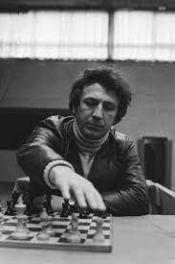
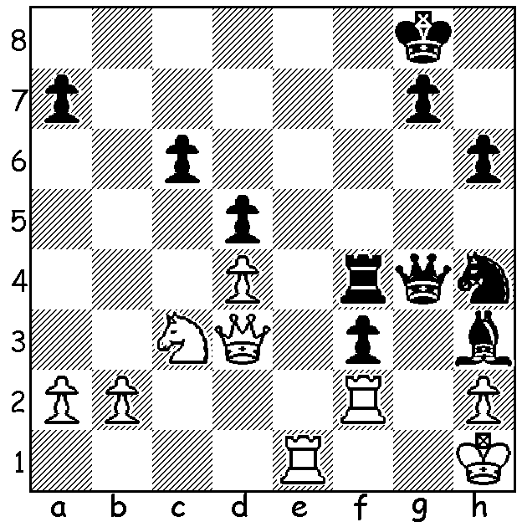
Eduard-Andrei Valeanu vs
Evgeny Sveshnikov 2006:
Black to play and mate in 3: Evgeny Sveshnikov

RECENT OPEN EVENTS IN WA

SOUTH WEST OPEN held at Evedon Lakeside Retreat, Burekup near Bunbury - 1st Tim Hare (5.5/6), 2nd Edward Calado (5); Under 1900 =1st Dylan Gough & Sanjay Mukhedkar (3.5); Under 1500 Sanjay Mukhedkar, =2nd John Prince, Varun Mukhedkar & Morgan Cumming (3) - Prince & Cumming shared the title of SW Country Champion.

WINTER ALLEGRO at the Abbey Winery (one of the Four Seasons events) - =1st Rebo Fu & Robert Maris (6/7); =3rd Jamie Laubbacher & David Ellis (5.5); Under 2000 1st Neville Shah (5), Under 1600 Iker Hernandez (4.5), Under 1000 1st Jun Wei Neo (4.5). Of note was the performance of WA Girls Champion Celine Ong (4.5) who defeated both Robert Maris and me.

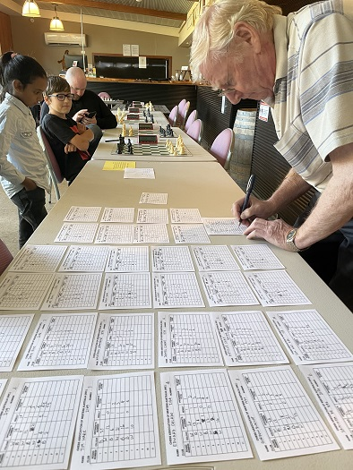
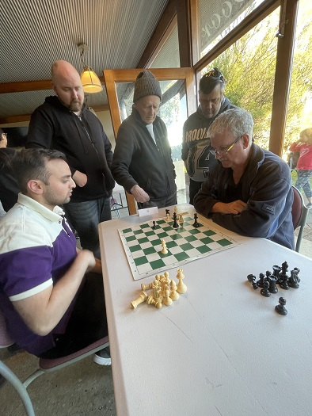
Winter Allegro

Last game to finish,
Neville Shah vs Gordon Dunlop

DOP Norbert Muller
preparing the next round

SOUTH OF RIVER CHESS FESTIVAL at Cirque Community Space, Brentwood - 1st David Ellis (4.5/5), =2nd Josh Davell & Angus Chen (3.5). A sensational performance by Angus (rated 893), the Under 8 and Under 10 WA Champion, who defeated top seed Andador Dominador (rated 2156), a previous winner of the event. This tournament was followed by Rapidplay & Blitz events.

SOLUTION : 1...Qg2+!! 2.Rxg2 Bxg2+ 3.Kg1 f2#. A second position from Evgeny Sveshnikov who died last month aged 71. The position shows all five attacking pieces contributing to the mate.

