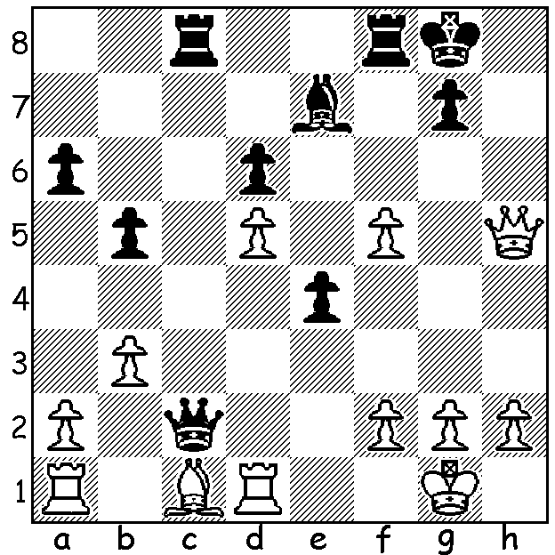
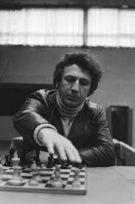
Mikhail Ulibin vs Evgeny Sveshnikov 1988:
Black to play and win (4 moves):

EVGENY SVESHNIKOV (1950 - 2021)
I recently presented positions from wins by Evgeny Sveshnikov who died in August this year. Today some details about this colourful figure. A talented youngster, Sveshnikov, born in 1950, played his first major tournament, the Soviet (USSR) Championship in Kharkov, where he scored a credible 7/13 in a field of 130 (won jointly by Mikhail Tal and Lev Polugaevsky). He graduated from university as a research engineer and worked for the Dept. of Internal Combustion Engines, regularly clocking up 12 hours a day. After leaving he was able to concentrate on his chess career and after a number of successes gained his GM (Grandmaster) title in 1977. In the 1990s he moved to Riga and began representing Latvia in international events. During his career he gained victories over a number of strong GMs, including Judit Polgar, Viktor Korchnoi, Nigel Short and Mark Taimanov. He is perhaps most well known for a variation in the Sicilian Defence, the Sveshnikov Variation, named after him (1.e4 c5 2.Nf3 Nc6 3.d4 cxd 4.Nc3 e5). He was also known for his strong advocacy of players’ rights regarding game scores which, he believed, should earn royalties from publishers.

WA EVENTS
WILLETTON OPEN (WA GP event) 9th & 10th October at Leeming Primary.
JUNIOR CAMP planned for coming school holidays has been deferred to the summer break.
WA JUNIOR RAPIDPLAY CHAMPIONSHIPS Thursday 30 Sept and Friday 1 October.
WA JUNIOR ALLEGRO CHAMPIONSHIP Sunday 3 October.
CARILLY SPRING ALLEGRO (4 Seasons) Sunday 17 October.
Details of events cawa.org.au

SOLUTION: 1...Rxf5! (deflection sacrifice) 2.Qg4 (2.Qxf5 Qxd1#) 2...Qxf2+ 3.Kh1 Qf1+! 4.Rxf1 Rxf1#. The position appears to be from a Sveshnikov Sicilian.

