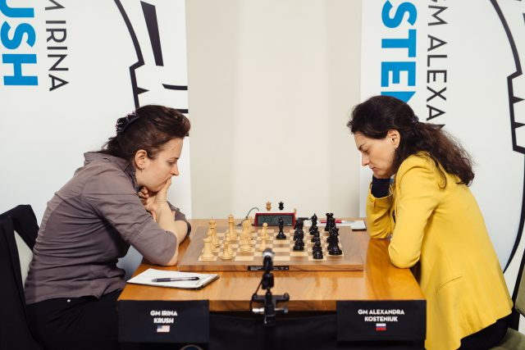
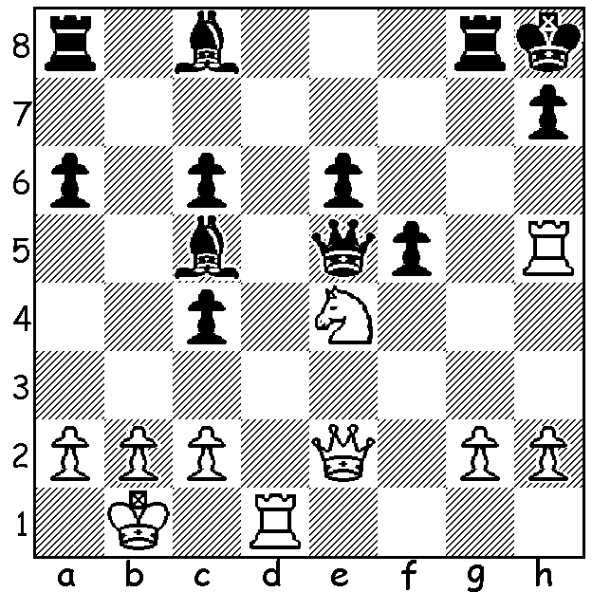
Irina Krush vs Alexandra Kostrniuk
Alexandra Kosteniuk (Russia) (at an earlier game)
v Irina Krush (USA)
(2021 Online Olympiad Final, Sept 2021)
White, a piece down, mates in 5 - brilliant!


The 2021 ONLINE CHESS OLYMPIAD (August – September) attracted 153 teams with over 1000 players involved. Squads had to include females and juniors and pairs of matches were played over 6 boards with a time limit of 15min + 15sec. A complicated series of preliminaries saw eight teams progressing to quarter finals with the four top rated
teams advancing to the semis where Russia defeated China
and USA defeated India. The final proved very close with
Russia winning both matches 3.5-2.5.
Top WA player GM Temur Kuybokarov, who played first
board for Australia in the Olympiad, has been selected as a
wild card on the very prestigious FIDE Chess.com Grand
Swiss in Riga, Latvia, (October / November) where two
players will qualify for the next Candidates to find a
challenger to the world champion. Temur, who is the
Australian Champion, has also recently been awarded an
Australian Distinguished Talent Visa (only 200 of these
visas are granted yearly out of about 130,000 applicants).

WA EVENTS (see cawa.org for details)
WA Junior Rapidplay (Thurs 30 Sept - Friday 1October) & WA Junior Allegro Sunday 3 October.
Willetton Open (WA Grand Prix) Sat 9 & Sunday 10 October.

SOLUTION: 1.Ng5!! Qc7 (1...Qxe2 2.Rxh7#; Black now hopes for 2.Rxh7+ Qxh7 3.Nxh7 Kxh7 when Black retains a material advantage) 2.Qe5+! Rg7 3.Rd8+! Qxd8 4.Rxh7+ Kg8 5.Qxg7#. Undoubtedly the best finish of the tournament with three deflection sacrifice offers in succession.

