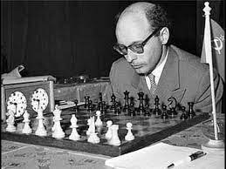
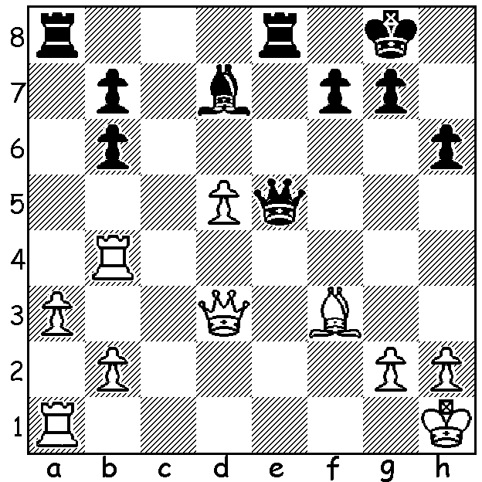

Vladas Mikenas vs David Bronstein David Bronstein, who drew a match for the
USSR Championship 1965: World Championship 12-12 against Mikhael
White with a strong passed pawn Botvinnik in 1951 after leading 11.5-10.5.
seems to have a good position
However he resigns after Black’s move.

THE DISPLACED KING
I had finished a game at the Metro club last month and a player who had noticed my game expressed an opinion that I had done well to recover from a bad opening when my king had been displaced on move four. The game had begun 1.d4 d6 2.c4 e5 3.dxe dxe 4.Qxd8+ Kxd8. It was my opinion that Black’s position was at least equal and next day I did some research on the Old Indian Defence, Ukrainian Variation (1.d4 Nf6 2.d4 d6 3.Nc3 e5) into which my game transposed. chess.com cites 6,397 games with the Old Indian Defence with the queen swap registering only 18.9% wins for White compared to 44.4% Black wins. Clearly the displaced king is no handicap and in fact is better placed for the endgame than a castled White king (the Black king usually finds safety at c7). Moreover the pawn at c4 is something of an impediment to White, depriving the f1 bishop of a useful diagonal. So why not give the Old Indian a try?

WA EVENTS OCTOBER (see cawa.org.au)
The WA Junior Allegro Championship tomorrow at N Woodside Primary
Willetton Open (WA Grand Prix) at Leeming Primary, Sat 9th and Sun 10th.
Carilley Spring Allegro (WA GP) at Carilley Estate, Herne Hill, Sunday 17th.

SOLUTION: 1...Rxa3!! (an amazing move as White seems to have the a pawn overprotected). However if 2.bxa3 Qxa1+, if 2.Rxa3 Qe1+!, if 2.Qxa3 Qe1+! and if Q retreats to back rank 2...Rxa1 3.Qxa1 Qe1+. You may recall last week’s problem (Kosteniuk-Krush) containing deflection sacrifices on 3 consecutive moves. Today 3 deflection sacrifices in one move with a fork thrown in for good measure. The game had begun 1.d4 Nf6 2.c4 d6 3.Nc3 c6 4.e4 e5 5.d5.

