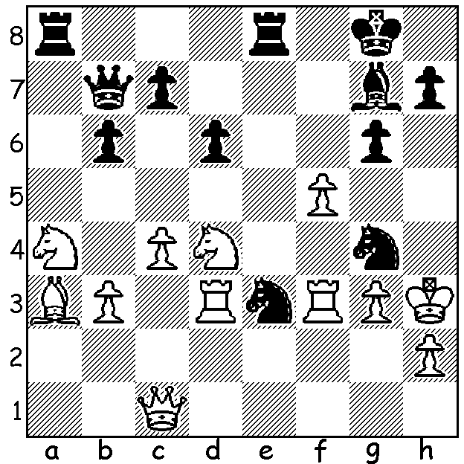
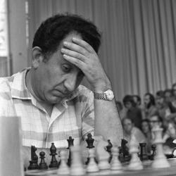

Alexander Kalantar vs Tigran Petrosian, defeated Botvinnik Tigran Petrosian 1946 to win world title in 1963, defended it Black has a mating attack (3 moves) against Spassky in 1966 before losing it to Spassky in 1969.

THE DISPLACED KING (2)
Last week I mentioned the Old Indian Defence, Ukranian Variation, where Black’s king is forced to move very early in the opening, 1.d4 d6 2.c4 e5 3.dxe dxe 4.Qxd8+ Kxd8. Today I switch to a Kings Pawn opening with something similar, the Berlin Defence to the Ruy Lopez (4.Nf6), where the main line goes 1.e4 e5 2.Nf3 Nc6 3.Bb5 Nf6 4.0-0 Nxe4 5.d4 Nd6 6.Bxc6 dxb6 7.dxe Nf5 8.Qxd8 Kxd8. This defence was considered antiquated until Vladimir Kramnik used it successfully when he took the world title from Garry Kasparov in 2000, drawing all four games where he used the Berlin. chess.com cites 13,913 Berlin games with White scoring 33.7% to Black’s 23.4%, making it the second most popular defence against the Ruy and the most successful in avoiding loss. It was also taken up by Vishy Anand in world championship matches against Magnus Carlsen who avoided the main line with 4.d3, the Anti-Berlin. The advantages of the main-line Berlin are the gain of the two bishops (2B + N vs B + 2N) and White being deprived of their queen, cutting down their attacking chances. The disadvantages are falling behind in development and giving White a superior pawn majority due to Black’s doubled queenside pawns. Today I’m not going to repeat last week’s advice, ‘why not give it a try’.

WA EVENTS OCTOBER (see cawa.org.au)
Willetton Open (WA Grand Prix) at Leeming Primary, Sat 9th and Sun 10th. Contact me at ellisd19@bigpond.com or 0439798607.
Carilley Spring Allegro (WA GP) at Carilley Estate, Herne Hill, Sunday 17th.

SOLUTION: 1…Qxf3! 2.Nxf3 Nf2+ 3.Kh4 Bf6#. Black employed the Old Indian with the opening
1.d4 Nf6 2.c4 Nf6 3.Nc3 e5 4.e4 exd 5.Qxd4 Nc6.

