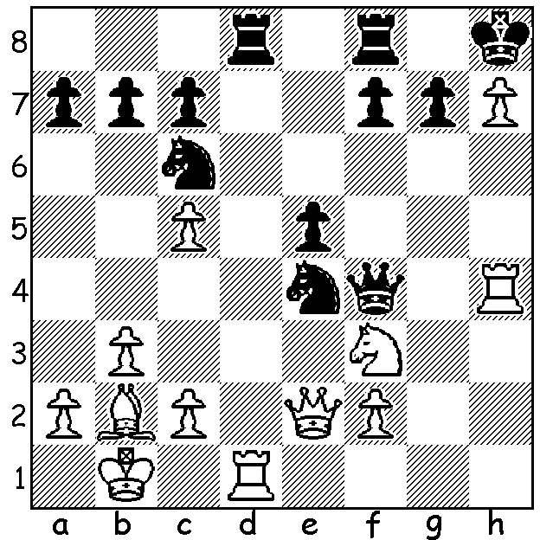
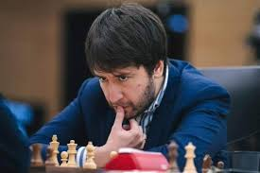
Spyridon Kaprisis vs Teimour Radjabov
Teimour Radjabov 1999
Black to play and win (4 moves):

CHAMPIONS CHESS TOUR FINALS
The Meltwater Champions Chess Tour event, which finished last month, was the tenth online event in the 2021 series bringing together the ten qualifying players headed by world champion Magnus Carlsen. Players competed against each other in a four game rapid play (15min + 10sec) mini match with drawn matches decided by two blitz (5min) games, followed by an Armageddon blitz game if needed with Black the winner in the event of a draw. The most successful player was Teimour Radjabov, followed by Hikaru Nakamura, Levon Aronian and Carlsen. However players took bonus points into the final from preliminaries enabling Carlsen to win the Tour with three rounds to go. He then lost two matches running before winning his final match against Wesley So.

Carilley Spring Allegro (WA GP) at Carilley Estate, Herne Hill, tomorrow, Sunday 17th. See cawa.org.au

The WILLETTON OPEN, a WA GP event, played last weekend, resulted in the state’s two top juniors taking out the first two prizes with Rebo Fu (5.5/6) edging out Jamie Laubbaccher (4.5) who drew three games. Winner of the Under 1800 group was another junior, Iker Hernandez Mendez (4) while two of the youngest competitors, Eric Deng and Eu Ming Khaw (both 2.5) shared the Under 1500 prizes. Juniors comprised half the entries and gained a lion’s share of the prizes which bodes well for the future of the game in WA. Other prizewinners in the 20 player event were: Open =3rd – Oscar Gao, David Ellis and David Barry (4); Under 1800 =3rd - Hui Huang, Kundan Dharmapuri, Tjermin Gunawan (3).

SOLUTION: 1...Rxd1+ 2.Qxd1 Qxf3! (winning a piece) 3.Qxf3 Nd2+ 4.Kc1 Nxf3.

