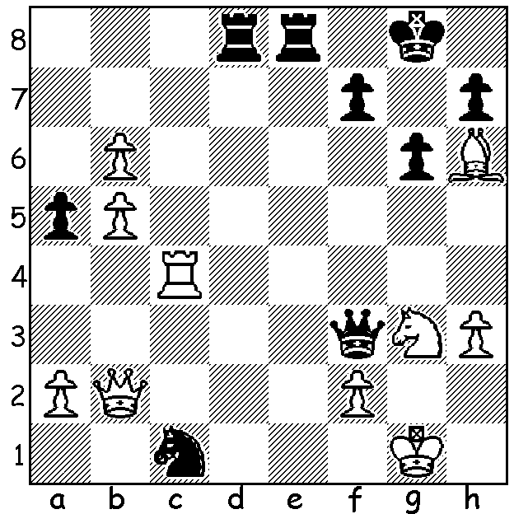
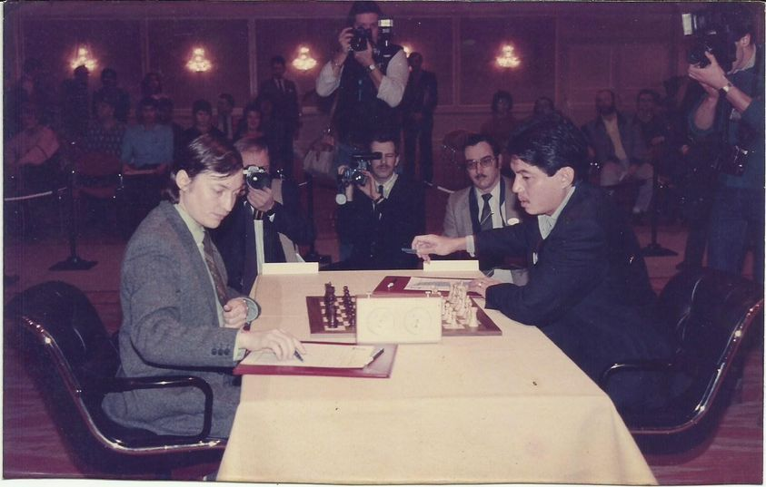
Florin Gheorghiu vs Eugenio Torre (rt) v Anatoly Karpov
Eugenio Torre 1972
Threatened with 1.Qg7# and 1.Rxc1,
Black finds a quick mate:

FIRST ASIAN GRANDMASTER
I recently came across an article about the first Asian male, Eugenio Torre from the Philippines, who was inducted into the Chess Hall of Fame in April this year (the first Asian inducted was Xie Jun, Womens World Champion 1991-96 & 1999-2001). Two other famous players inducted at the same time were Judit Polgar and Polish-Argentinian Miguel Najdorf. The awards are on the recommendation of FIDE (International Federation of Chess) while the Hall, founded in 1984 and situated in St Louis, USA, is a Museum of all things Chess.
Eugenio Torre’s award recognises his career and influence upon Chess in Asia. He was born in 1951 and in 1974 he became the first Asian Grandmaster. He played Board 1 for the Philippines in 17 Olympiads and in 1982 qualified for the Candidates, a tournament to decide a challenger to the world champion. His highest placed rating was 17th in the world and he was the only player to defeat Anatoly Karpov in the year of 1976 after Karpov had been awarded the world title. He acted as second to Bobby Fischer in his rematch against Boris Spassky in 1992.

The next WA GP event will be the KINGSLEY OPEN on two successive Sundays, 7 & 14 November. Note this is on successive Sundays, not Sat/Sun. See cawa.org.au

SOLUTION: 1…Ne2+! (obstruction sacrifice) 2.Nxe2 Rd1+ 3.Kh2 Qxf2#.

