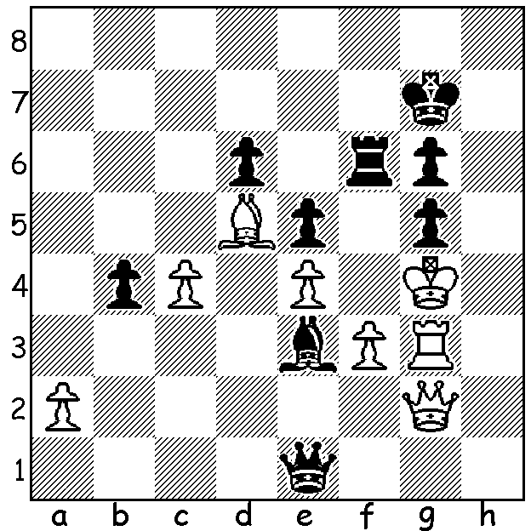
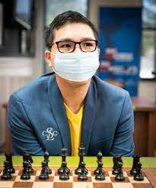
Chan Wei Xuan vs
Wesley So, 2007 Wesley So at St Louis, who retained
Black mates in 3: his title as US champion

US CHAMPIONSHIP 2021
The recently completed US Championship, was held at the St Louis chess club, the venue since 2019 (with the exception of last year when, due to the covid pandemic, it was played online). Twelve of the top players clashed in a round-robin, the most notable absentee being four times winner Hikaru Nakamura whose activities are more and more centred on online chess with faster time controls. Despite a ruling forbidding draws by agreement, 42 of the 66 games were drawn. While nine of the players were in the age range 20 – 29, only three were older (32-39). The tournament finished in a three way tie with Fabiano Caruana, Wesley So, one of only two unbeaten players, and Samuel Sevian, all scoring 6.5/11. A rapidplay playoff saw So defeat both his rivals to win the title for the third time.

The next WA GP event will be the KINGSLEY OPEN on two successive Sundays, 7 & 14 November at N Woodvale Primary. Note this is on successive Sundays, not Sat/Sun. See cawa.org.au

SOLUTION: 1…Rf4+ 2.Kxg5 (2.Kh3 Rh4#) 2...Bb6! (2...Rxe4+ clearly wins but White delays mate with 3.f4); now 3...Bd8# cannot be prevented. It is often easy to overlook retreats which paradoxically are attacking moves.

