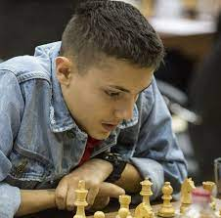
Robert Hovhannisyan
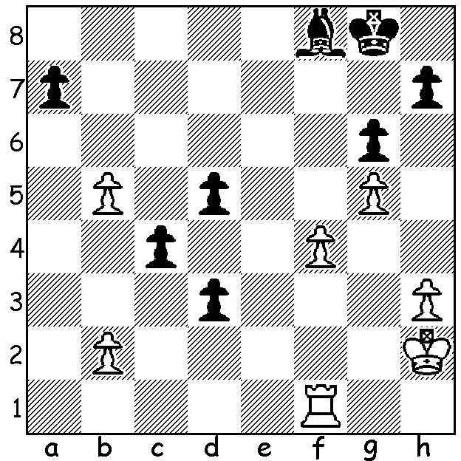

Temur Kuybokarov at Riga
Jorden Van Foreest
(Grand Swiss, Rd 2):

Black to play. Will he win, lose or draw? Devise a plan and state your first move.

TEMUR IN LATVIA
Australian champion, twenty-one year old West Australian Temur Kuybokarov is at present playing in the Grand Swiss chess tournament in Riga, Latvia. The top two finishers of this 11 round 108 player event will qualify for the 2022 Candidates, a tournament to provide a challenger to the world champion. This has ensured that a host of the world’s top Grandmasters are competing, such players as Fabiano Caruana, Maxime Vachier-Lagrave, Alireza Firouzja and Levon Aronian. The average rating of this all-Grandmaster event is 2639 and while Temur’s rating is 2549 he was on 50% or above until a second loss dropped his score to 2.5/6. Games can be followed or replayed on a number of chess websites. CAWA has launched an appeal via Trybooking to help meet the very considerable expenses of the Kuybokarov family and I would encourage readers to support this.

The KINGSLEY OPEN (WA GP event) starts on Sunday at Woodvale Primary and concludes the following Sunday, November 14. Note this is on successive Sundays, not Sat/Sun. See cawa.org.au

SOLUTION: Clearly Black’s chances lie with his three advanced pawns with the two obstacles to promotion being the b2 pawn and the rook. Therefore eliminate one of the obstacles as quickly as possible! 1...Ba3!! and after 2.bxa3 the advance of the united passed pawns with 2..c3 or 2...d2 ensures a new queen. Always remember, united passed pawns on the 6th rank defeat a lone rook.

