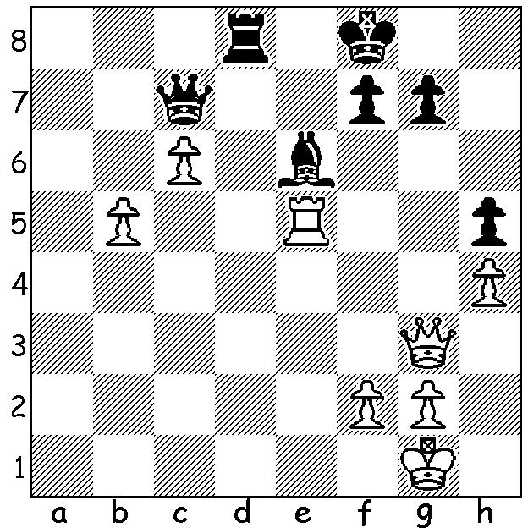
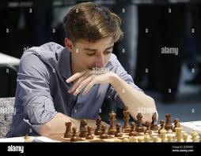
Daniil Dubov vs Ivan Saric Young Russian Daniil Dubov
(Grand Swiss 2021, Rd 6):
White a piece down for
two pawns finds a win.

TEMUR IN LATVIA (2)
Australian champion, twenty-one year old West Australian Temur Kuybokarov, finished the Grand Swiss in Riga, Latvia, with a score of 5.5/11 (+2 =7 -2). Considering he was invited as a wild card and that the event included among its 108 players four of the world’s top ten it was an excellent performance. Among others who scored 50% were many times Russian champion Peter Svidler and a former challenger to the world title Boris Gelfand.
Round 9 saw the Iranian now French player Alireza Firouzja lose his sole lead when beaten by world number 3 Fabiano Caruana which left three players, Firouzja, Caruana and David Howell (England), sharing the lead and ten players including Maxime Vachier-Lagrave and former world number 2, the veteran Alexei Shirov, a half point behind. However in Rd 10 Firouzja regained sole lead by defeating Howell and with top boards all registering draws in the final round Firouzja finished sole winner with 8/11. Caruana and Grigoriy Oparin (Russia) finished with 7.5 with Caruana taking second place on tie break. Thirteen players on 7 took out positions 4-16. Firouzja and Caruana’s success qualifies them for the next Candidates to determine a challenger for the world title.
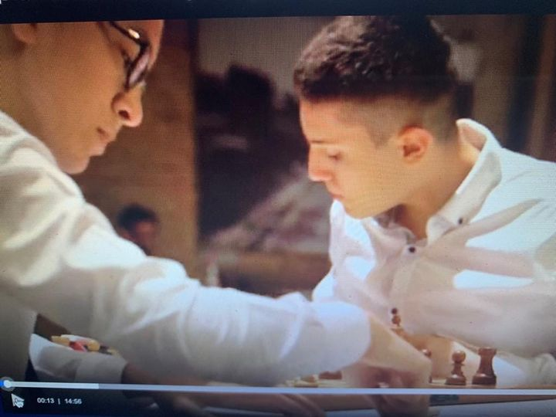
SOLUTION: 1.Rxe6!! Qxg3 (1...Rd1+ 2.Kh2 doesn’t
help) 2.fxg3 fxe6 3.c7. Now if 3...Rc8 4.b6 / 5.b7 wins.
Black tried 3...Ke7 but lost to 4.cxd8=Q+ Kxc8 with the
capture of White’s b pawn enabling White to eat up all
Black’s pawns (the winning potential of the outside
passer in K+p endings). Hands up those who spotted
the similarity to last week with advanced united
passed pawns defeating a rook.

Temur in play in Riga

