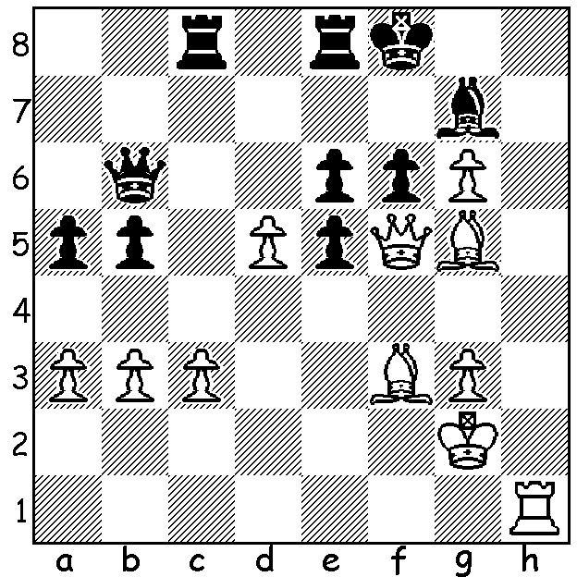
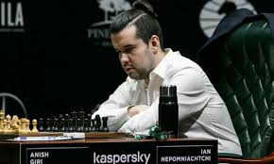
Ian Nepomniachtchi
vs Alexander Volodin 2006:
Find a mate for White:

TO SLIM DOWN OR TO BULK UP?
The date millions of chess players will be looking forward to is November 24 when Magnus Carlsen defends his world title in a 14 game match against Ian Nepomniachtchi in Dubai. Naturally both players will have studied hard with engines and seconds, analysing the opponent’s games to search for any weaknesses and preparing their opening play, if possible with new moves. They will also try to start the match in peak physical condition to help meet the exhausting demands of the match. One of Calsen’s previous challengers, Fabiano Caruana, prepared for his match with a regular course of five mile runs, an hour of tennis, half an hour of basketball and an hour of swimming while the somewhat bulky Nepo has slimmed down by 10kg to become fitter. However a concern for match players is likely to be avoiding weight loss during a match as scientific tests have shown that players can expend up to 6000 calories a game, about 50% the rate of top tennis players, the reason being the stressful nature of the game, made worse by the demands of clock management, resulting in increased heart rates and elevated blood pressure. The then world champion, the slightly built Anatoly Karpov lost nearly 10kg after 48 games against Gary Kasparov with the match abandoned due to the danger to Karpov’s physical well-being. No surprise then that a personal chef is part of Carlsen’s entourage to help keep him fit. Finally a quote from former leading player Bent Larsen: ‘the stomach is an essential part of a chess master’.

SOLUTION: 1.Qxf6+!! Bxf6 2.Bxf6 and Black is unable to prevent Rh8#.

