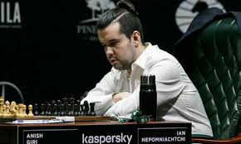
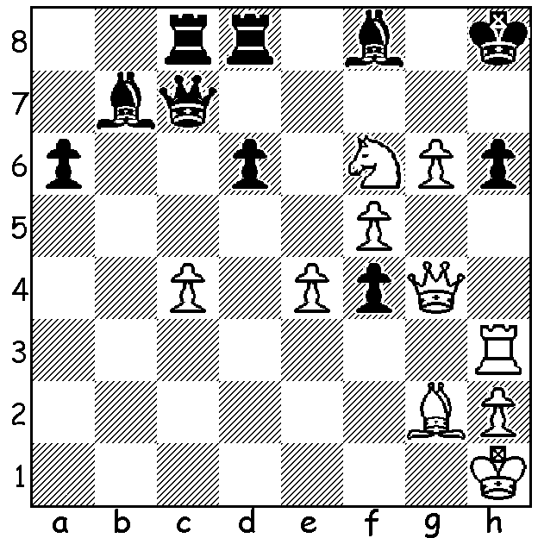
Ian Nepomniachtchi vs Maxim Matlakov 2000: Ian Nepomniachtchi
White, a rook down, has a mating attack:

WILL IT BE MAGNUS OR NEPO?
With the world championship having recently begun let’s have a look at the career of the challenger, Russian GM Ian Alexandrovich Nepomniachtchi. Born in July 1990, Nepo learnt to play when aged four and a half. In 2002 he win the World Youth Championship, edging out Magnus Carlsen. He became a GM in 2007, won the European Championship in 2010, the same year he won the Russian Championship (he also won the Russian title in 2020). In 2021 he won the eight player Candidates with 8.5/14, half a point ahead of Maxime Vachier-Lagrave, thus earning himself the right to challenge Carlsen. He has an attacking style with his favourite opening being the Ruy Lopez (1.e4 e5 2.Nf3 Nc6 3.Bb5) with the English Opening (1.c4) being a second choice. As Black he regularly uses the Sicilian Defence (1.e4 c5) and sometimes the French (1.e4 e6) while the Grunfeld (1.d4 Nf6 2.c4 g6 3.Nc3 d5) is his most usual defence against 1.d4. The match will be over 14 games (time control 40 moves in 2 hours, then one hour for another 20 moves and finally 15 more minutes with 30 sec increments to the end). In the event of a 7-7 draw, rapid games will be used to determine a winner. Most experts expect Carlsen to win a close match but rate Nepo’s chances as 40-45%.

SOLUTION: 1.g7+! Bxg7 (1...Qxg7 2.Rxh6+! Qxh6 3.Qg8#) 2.Qg6 winning – 2...Bxf6 3.Rxh6+ or 2...Bf8 3.Qg8#.

