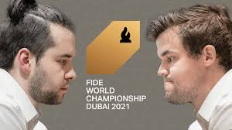
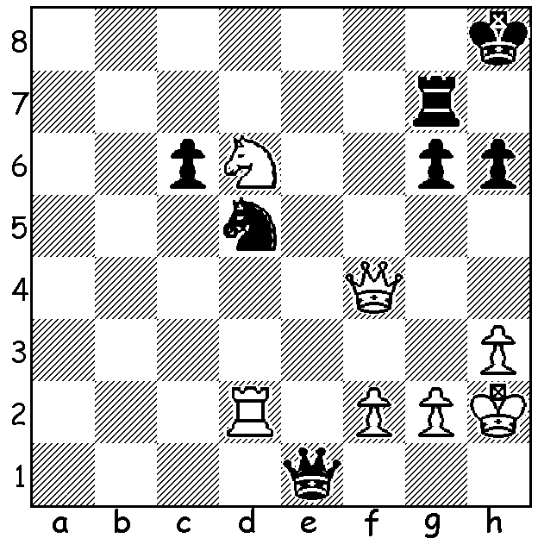
Nepomniachtchi & Carlsen
Magnus Carlsen vs Alexander Morozevich 2006
How does White create a winning attack?

WILL IT BE MAGNUS OR NEPO (2)?
Last week it was a look at the challenger for the world title, Russian GM Ian Alexandrovich Nepomniachtchi, and today it’s world champion Magnus Carlsen. Magnus was born in 1990, the same year as Nepo, so age will have no relevance to the outcome. However in terms of experience the odds certainly favour the champion. A child prodigy and a Grandmaster at 13, Magnus first became the top rated player in 2010 and trails only Gary Kasparov in time spent as number 1. His peak classical rating of 2882 is the highest in history (he is currently 2855). He also holds the record for the longest unbeaten streak at the top level in classical chess, 125 games. He has been Classic, Rapidplay and Blitz world champion and in 2014 world champion in all three concurrently. Magnus became world champion after defeating then champion Vishy Anand in 2013 and has successfully defended the title three times - against Anand, Sergey Karjakin and Fabiano Caruana. Magnus is not seen as having any particular strengths or weaknesses and plays a very large variety of openings and defences making it hard for an opponent to prepare against him. Former champion Vishy Anand thinks that Magnus will try to steer games into simple positions where he has a slight advantage
and might be vulnerable in complex positions but questions whether Nepo will be able to obtain such positions. As for the mindset of the players, he says of Magnus, “It’s already his fifth match and I don’t think the fire is burning so hard nowadays,” while of Nepo he says, “Ian has huge swings and that is a big question mark.”
Games 1-3, all very interesting and complex with relatively new ideas in the openings, were draws.

SOLUTION: 1.Rxd5! (destroying the guard of f6) 1...cxd5 2.Qf8+ Kh7 (2...Rg8 2.Qxh6#) 3.Ne8 Qd5+ 4.f4 Qe7 5.Nf6+ wins the queen.

