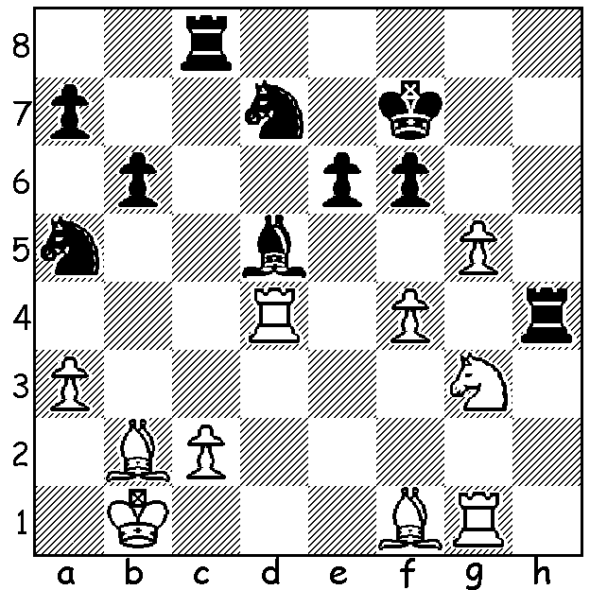
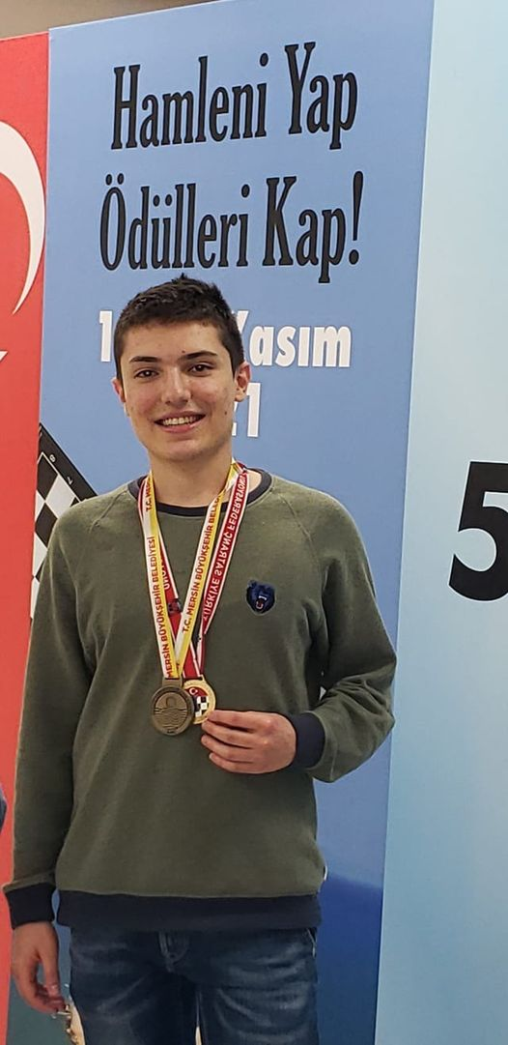
Temur Kuybokarov vs C R G Krishna 2021
How does White win material?

Temur Kuybokarov, winner in Turkey

TOURNAMENT SUCCESSES FOR WA GM
Since his arrival in Australia in 2016 Temur Kuybokarov has had an outstanding run of successes, winning the Penang Open in 2016, the Australian Open in 2017 and 2019, the Gold Coast Open in 2018 and the Australian Championship (Closed) in 2020. He was awarded his Grandmaster title in 2018, aged 18. This year he played in the FIDE Grand Swiss in Riga, Latvia, scoring a very creditable 5.5/11 in a 100+ player tournament which included many of the world’s top GMs and followed up by winning the Mersin Open, Turkey, with 7.5/9.
Temur, originally from Uzbekistan, was taught to play by his mother when he was 5 and in 2010 was =1st in the Under 10 Asian Youth Championship in Beijing. Aged 11 he defeated world champion Vishy Anand in a Simultaneous Display.
His family moved to Perth in 2019 and that year Temur was named as one of WA’s 50 rising stars. His father Gayrat came to Australia on a business visa and his mother Tatania recently qualified as a teacher with the WA Education Board. All the family hope to receive Australian citizenship soon and wish to thank the WA chess community for its continued support.

WORLD CHAMPIONSHIP: with wins in Games 6, 8 and 9, world champion Magnus Carlsen has built up a three point lead over challenger Ian Nepomniachtchi in their 14 game match.

SOLUTION: 1.g6+! and if 1….Kxg6 2.f5 + Kg5 3.Bc1+ (2.Nf5+ also wins – 2...Kxf5 3.Bd3+ Be4 4.Bxe4+ Kxf4 7.Bd3+ / 8.Rxh4); Black played 1...Kg8 when 2.Rxd5! exd5 3.Nf5 Rxf4 4.Ne7+ Kg7 5.Nxc8 wins. Alternatives are no better: 1...Kg7/e7 2.Rxd5! exd5 3.Nf5+ / 4.Nxh4; 1...Ke8 2.Rxd5+ exd5 3.Nf5 Rh8 4.g7 Rg8 5.Nh6 Ke7 6.Bd3 / 7.Bh7.

