NEPO’S FOUR STEPS TO DISASTER

Carlsen vs Nepomniachtchi (Game 6) Carlsen vs Nepo (Game 8)
Black played 36...Qd5. What did he miss? Black played 27….b5. Why is this wrong?
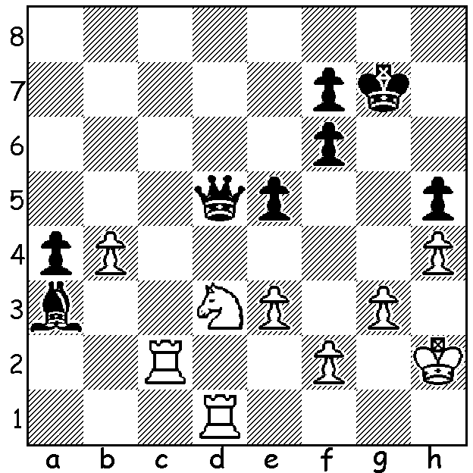
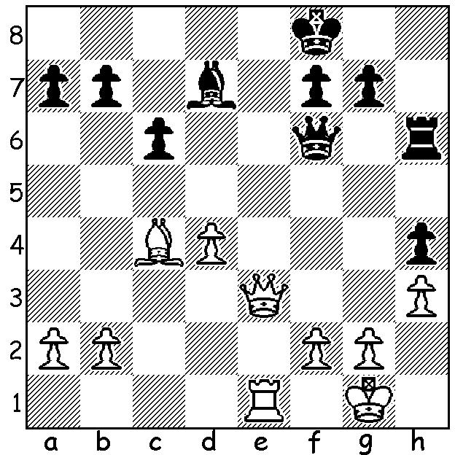
Nepo vs Carlsen (Game 9) Nepo vs Carlsen (Game 11)
White plays 27.c5. Why is this wrong? White plays 23.g3. How does black win?

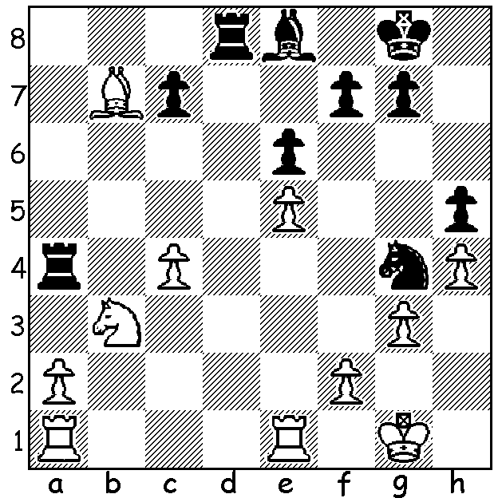
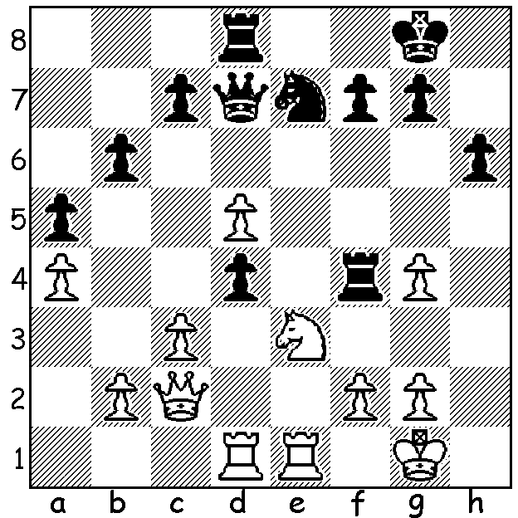

After pressing champion Magnus Carlsen in Games 1-5, the loss in Game 6 started a collapse by Ian Nepomniachtchi in their world championship match to lose 3.5-7.5. These positions highlight four steps to his defeat.

SOLUTIONS:
1: Game 6 was the longest game ever in World Championship matches, lasting 136 moves. Nepo had given up his two rooks for the queen but in time trouble missed 36...Bxb4!
2: 21...b5? 22.Qa3+ Kg8 23.Qxa7 Qd8 24.Bb3 and White won a queen ending. (Always look at checks!)
3. 27.c5? c6 and the bishop on b7 is trapped.
4. 23.g3? fxe3! 24.gxf4 Qxg4+ with a winning attack.

