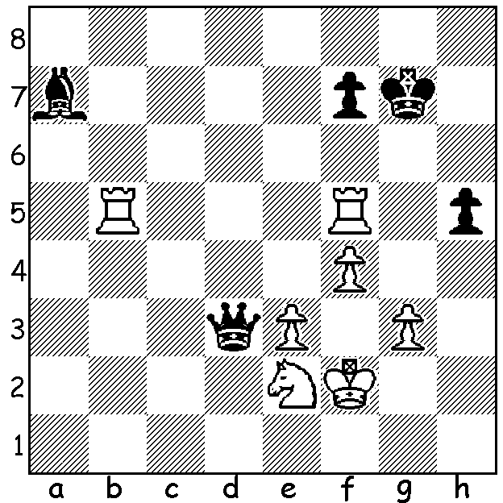

From the match-changing marathon sixth game of the Magnus Carlsen - Ian Nepomniachtchi world championship which Magnus won 7.5-3.5 after the first five games were drawn. How did White ensure all the winning chances (3 moves)?

WILL MAGNUS DEFEND HIS TITLE AGAIN?
Carlsen has hinted he may relinquish his world title, citing lack of motivation, although the prospect of defending the title against one of the young stars, especially Alireza Firouzja, now ranked world number 2, might be appealing with Carlsen now 31 and Firouzja 18. However his ambition is to become the first player to achieve a ranking of 2900. Here are Carlsen’s world championship results:
2013 Chennai defeated champion Viswanathan Anand 6.5-3.5 (+3 =7);
2014 Sochi, Russia defeated Anand 6.5-4.5 (+3 -1 =7);
2016 New York defeated Sergey Karjakin 2-0 in play-off after 6-6 (+1 =10 -1)
2018 London defeated Fabiano Caruana 3-0 in play-off after 6-6 (=12)
2021 Dubai defeated Ian Nepomniachtchi 7.5-3.5 (+4 =7).
Total games 61 with 16 wins 43 draws 2 losses.

SOLUTION:
80.Rxf7+! Kxf7 81.Rb7+ Kg6 82.Rxa7. A good example of simplification with Carlsen making a small sacrifice to leave Black a lone queen unable to counter the combination of rook, knight and the two united passed pawns with Black resigning after 136 moves.

