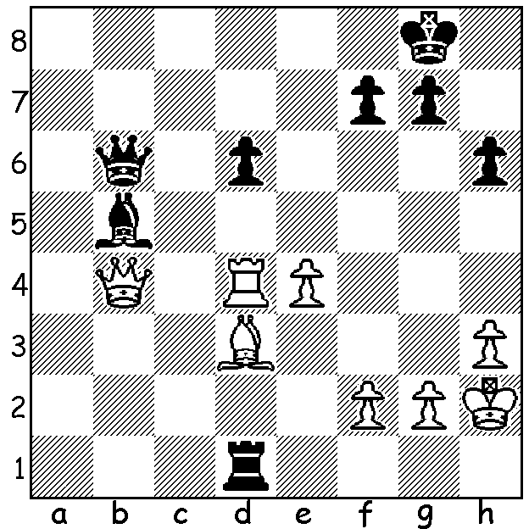

Maxime Vachier-Lagrave
vs Vladislav Artemiev 2017-
With both bishops and the
Black queen pinned White
wins with a subtle move
(3 moves):

MAGNUS LOSES TWO WORLD TITLES IN A WEEK.
After his dominating defence of his world title match against Ian Nepomniachtchi, Magnus Carlsen travelled to Warsaw to defend his Rapid and Blitz titles. The 181 player, thirteen round Rapid (15 min + 10 sec) finished with four players, including Magnus and Fabiano Caruana, scoring 9.5/13. However Magnus did not then have the opportunity to defend his title as the rules for the event only allowed for the top two players on tie-break to compete in a play-off, described by Magnus as ‘completely idiotic’, a view supported by many grandmasters. This gave Nepo the chance to win one world title but he again came off second best losing the play-off to the sensation of the tournament 17 year old Nodirbek Abdusattorov 0.5-1.5. Abdusattorov, from Uzbekistan, became a GM aged 13 years 1 month and 11 days and is the youngest player ever to win one of the three world titles.
The Rapid was followed by the 176 player, 21 round World Blitz (3 min + 2 sec) which again finished with multiple top scorers, Maxime Vachier-Lagrave (France), Jan-Krystof Duda (Poland) and Alireza Firouzja (France), all 15/21 (Carlsen =8th on 13.5). After Firouzja was eliminated on tie-break, MVL defeated Duda 2-1.Three players, including one of the favourites, Hikaru Nakamura, were forced to withdraw during the event after contracting Covid.
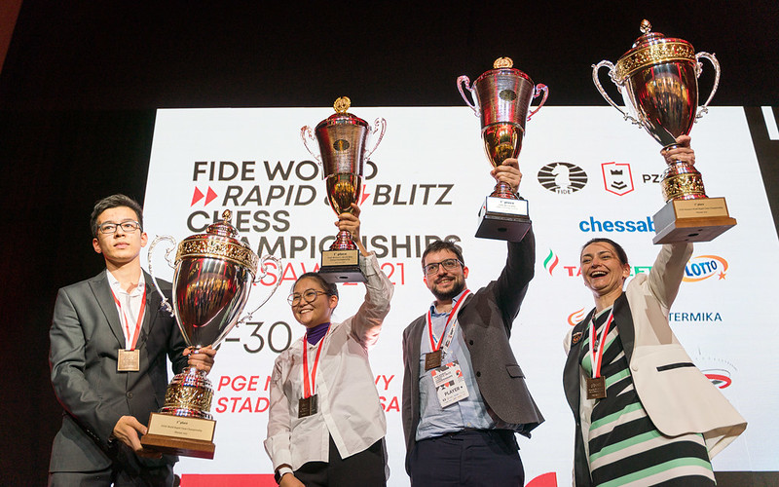
Four winners: Nodirbek Abdusattorov, Bibisara Assaubayeva (Women’s Blitz),
MVL, Alexandra Kosteniuk (Women’s Rapid)

SOLUTION: 1.e5!! (depriving the Black king of an escape as well as threatening 2.exd and 2.Bh7+) if 1...dxe 2.Qxb5! Qxd4 3.Qe8# (1...Qxd4 trying to achieve a fortress with R & B fails to 2.Qxd4 Rxd3 3.Qb4 Bd7 4.Qb8+ Kh7 5.Qb1 Bf5 6.exd! Rxh3+ 7.gxh3 Bxb1 8.d7).

