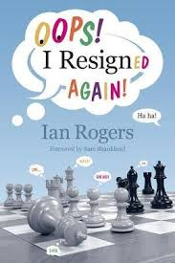
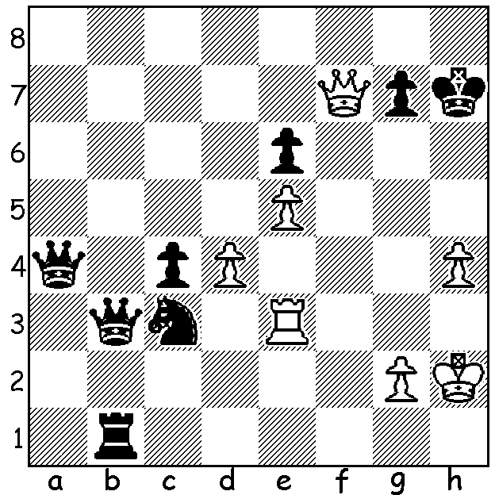

Tony Akers vs James Turner 2008:
After 1.Rg3 Black gave the spite check 1...Rh1+ and then resigned after 2.Kxh1.
Can you see how with his enormous material advantage he could have won?

OOPS, I DID IT AGAIN!
I wonder how many readers can recognise the heading as a title of a Britney Spears hit. You may wonder what this has to do with chess but it is the inspiration of the title of a recent book by GM Ian Rogers, Oops! I Resigned Again! The book contains one hundred positions in which a player gave up when he could have won or at least maintained equality. There is much to like about this book: it is very well set out, conveniently divided into chapters of five puzzles and their solutions; it includes positions both historical and recent, including a goodly number from Australia; it gives the positions with the move or moves prior to the resignation; it is not just a book of puzzles but each page contains interesting information on the players and tournament.
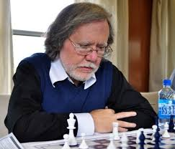
For those not familiar with the name Ian Rogers
here are a few details. Ian was born in 1960 and in 1985
became the first Australian-raised Grandmaster. He was
Australia’s highest rated player for over twenty years and
represented Australia at fourteen Olympiads, twelve on
Bd 1. He won more than 120 classical chess tournaments,
including four Australian championships. He retired from
competitive chess in 2007 on medical advice but has
continued his involvement on chess as a trainer, a reporter
at major events and writer.

SOLUTION: 1...Rh1+ 2.Kxh1 Qa1+ 3.Kh2 Qg1+!!
4.Kxg1 Ne2+ 5.Kf2+ Nxg3. A comical example from
Oops! I Resigned Again! Rogers writes: “Rarely is a resignation so misguided that a player earns a nickname from it, but this was the case for James ‘Two Queens’ Turner after this game.”

