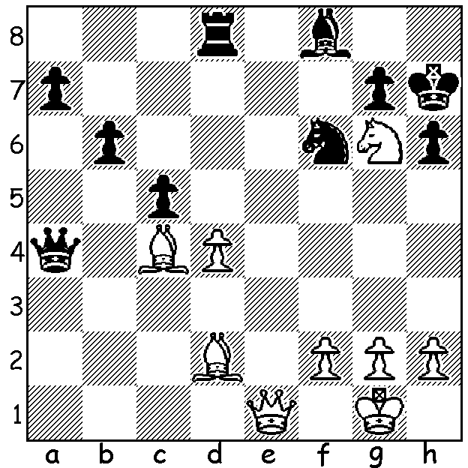
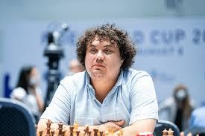
Lanton Korobov vs Korobov at Cattolica
Subtamaniyam Bharath
Vergani Cup 2022:
White wins with a sensational mate (4 moves):

LUCK COMES CALLING
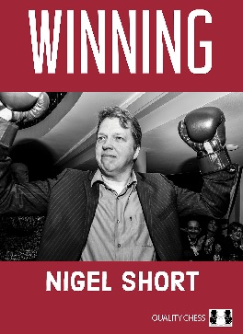
Smartphones are now being used to alert owners of possible covid contact and this has in many cases meant the relaxation of the rule for players not to have phones on their person. An opponent’s phone ringing recently gave Nigel Short an undeserved point in the Vergani Cup, a Swiss tournament with 124 players in Cattolica, Italy. Nigel, a former challenger for the world title and now Vice-President of FIDE, toured Australia including Perth giving lectures and simuls in 2016. He was diagnosed with covid during the second week of December, ending up in a London hospital where he was put on oxygen. After about a week he was discharged, although far from fully recovered, and on January 2 took his place at the board in Cattolica. In Rd 2 he faced 14 year old Lorenzo Candian, rated only 1952 to Short’s 2633, but he was outplayed and forced to surrender the exchange. However the ringing of the youngster’s phone meant an automatic forfeit. Nigel finished well down with 5/9 which included a loss on time in Round 9 when forgetting about the clock.

Nigel has had his most recent book, simply called
Winning with a front cover showing Nigel in boxing gloves,
being chosen as the outstanding chess book of 2021. It
highlights eight of his greatest tournament victories together
with accompanying annotated games.

The book Oops! I Resigned Again! by Australia’s Ian
Rogers, which I reviewed last week, can be obtained from
the author for $30, which includes postage,
gmianrogers@gmail.com

SOLUTION: 1.Qb1!! Rxd4 (1...Qxc4 2.Ne5+) 2.Nxf8+ Kh8
3.Qh7+!! Nxh7 4.Ng6#.

