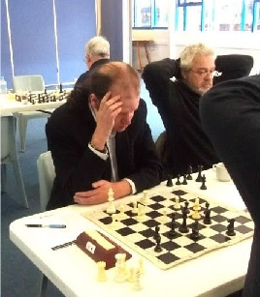
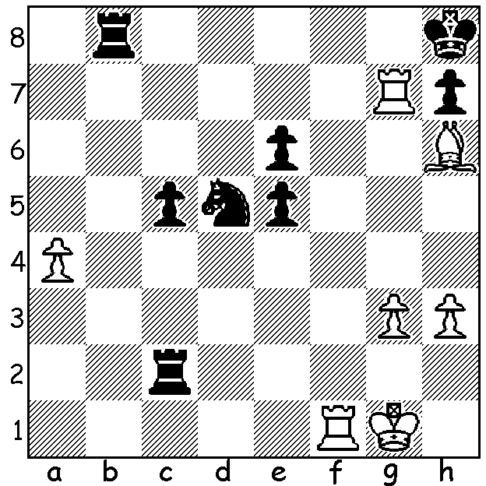
Kevin Bonham vs Neil Markovitz 2011
White now played 1.Rb7! and after Kevin Bonham with Denis McMahon
1...Rg8 2.Rff7 Black resigned believing
he would be mated after 2...Rxg3+ 3.Kf1.
What saving move did he miss?

MEETING OF TWO EX-PRESIDENTS
In December I had a fortnight touring the beautiful island

of Tasmania which gave me an opportunity to renew an
acquaintance with Denis McMahon, a fellow former WA
Chess Association president, who now resides in Devonport on the north coast. Denis, a retired English high school teacher has been the president of the Tasmanian Chess Association for a number of years and has been winning a number of events in the Apple Isle. He has also set up a small local club (conveniently next door to his home).
Denis was for many years a stalwart of chess in WA, being the mainstay of the Fremantle CC and co-ordinator of the Secondary Schools Chess League. However Denis’s
abilities have not been confined purely to chess. He has
represented Australia in Debating and has written books Meeting of two former presidents -
of poetry including ‘Idle and Drunk in Heaven’ which was No, Not Obama and Clinton
published while he lived in WA.
SOUTHERN SUBURBS OPEN will be start on Tuesday February 8 and run for seven weeks. Being an open event members of other clubs are very welcome to participate. The club’s junior club will also be starting soon, Tuesday February 1, 6-7pm and would welcome youngsters wanting to progress in the game. Contact Andrew Hardegen 0407421084. Check cawa.org.au for other events.

SOLUTION: Keeping the theme of Tasmania with this position from Ian Rogers’ Oops! I resigned Again’, which occurred when local player Kevin Bonham was playing in the Hobart Championship against visitor Neil Markovitz (whose daughter, WGM Lara Stock, was also competing). Play went 1.Rb7! Rg8 (1...Rxb7? 2.Rf8#) 2.Rff7 when instead of resigning Black could have played 2...Rxg3+ 3.Kf1 Rcg2= which defends against 4.Rb8+ Rg8 5.Bg7#.

