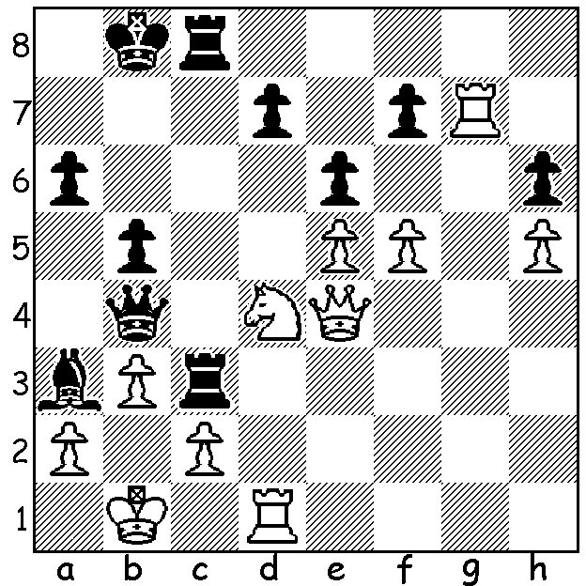
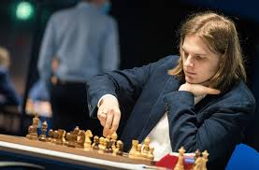

Nils Grandelius vs Richard Rapport (pictured)
Tata Steel 2022: not difficult to see where Black
wants to mate but a very precise preliminary move
is required, setting up an alternative mate:

TATA SCORE - PLAYERS 13, COVID 1
The annual Tata Steel tournament in Wijk aan Zee, Netherlands (14 invited players), was, like many other sports, affected by the virus with Daniil Dubov forfeiting against Anish Giri when he refused to wear a mask after one of his support team had tested positive. Dubov himself later tested positive with his final three games forfeited. This had a minimal affect on the results with world champion Magnus Carlsen winning comfortably in scoring 9.5/13 with 6 wins (1 a forfeit) and 7 draws, well ahead of Shakhriyar Mamedyarov and Richard Rapport, both 8/13. Carlsen’s tournament rating was 2902, a performance he will have to repeat on a number of occasions to achieve his ambition of reaching 2900 when ratings over an official period are calculated. This was Carlsen’s eighth win of the event since 2008.
The Tata Steel tournament began in 1938 (then called the Hoogovens tournament) and has been played every year since except 1945 with its winners having included world champions Max Euwe, Tigran Petrosian, Boris Spassky, Mikhail Botvinnik, Mikhail Tal, Anatoly Karpov, Vishy Anand, Garry Kasparov.

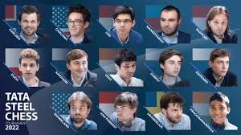
Tata Steel 2022 players; How many can you recognise? (answer below).

FORTHCOMING EVENTS (check details cawa.org.au): Chess Arena Carnival in Subiaco tomorrow (a fun event for old and young); Southern Suburbs Open (7 Rds) starting February 8; Perth Open (12 & 13 February).

SOLUTION: 1...Rh3! 2.Qe1 (stopping ...Qc3/Qb2#) 2...Rh1!! (deflection - if 3.Qxb4 Rxd1#) 3.Rg1 (3.Qxh1 Qc3) 3.Rg1 Rxg1 4.Qxg1 Qc3 / ...Qb2#.

Players:
Top row: Magnus Carlsen Norway 9.5), Fabiano Caruana (USA 6.5), Anish Giri (Netherlands 7), Shakhriyar Mamedyarov (Azerbaijan 7.5), Richard Rapport (Hungary 7.5);
Second row: J an-Krzysztof Duda (Poland 6), Sergey Karjakin (Russia 7),
Vidit Gujrathi (India 6), Daniil Dubov (Russia 3.5), Andrey Esipenko (Russia 6.5),
Bottom row: Sam Shankland (USA 5.5), Jordan Van Foreest (Netherlands 7),
Nils Grandelius (Sweden 4), Rameshbabu Praggnanandhaa (India 5.5)

