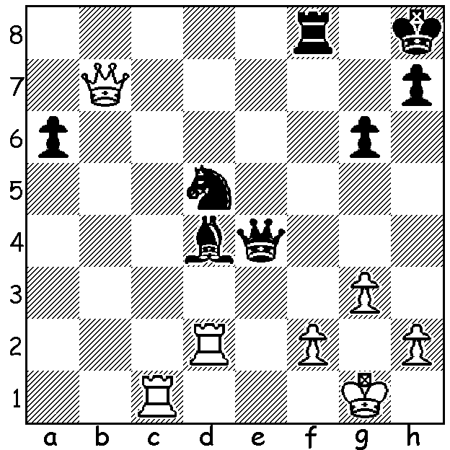

Arjun Erigaisi at Tata Steel
Daniil Dubov vs Arjun Erigaisi 2021:
Black to play and gain a winning position;
Simplification is the key (twice):

CONVINCING VICTORY IN TATA STEEL RESERVES
While the attention at chess tournaments is invariably centred on the main event, there are usually other events catering for players of lesser strength. Often there is a Reserves competition with the winner promoted to the following year’s top group. This year at Tata Steel, Wijk aan Zee, the Challengers Tournament was won in emphatic fashion by 18 year old Arjun Erigaisi with the score of 10.5/15, a full two points clear of joint second placed players. (Magnus Carlsen won the main event with 9.5/13), In Grandmaster events it is exceptional for a player to have such a high ratio of wins to draws, in this case eight wins to five draws. Erigaisi is from India and earned his Grandmaster title shortly before his fifteenth birthday. His tournament rating performance at Tata Steel was 2800+ which propelled his FIDE rating to 2659, putting him among the world’s top 100 players.

SOLUTION: 1...Rxf2! 2.Rxf2 (a back rank check is met by 2...Rf8+) 2...Bxf2+ 3.Kxf2 Qe3+ 4.Kg2 Qd2+! 5.Kh3 Qxc1 6.Qxd5 Qf1+ 7.Kg4 (7.Kh4 Qf6+ /8.Qf5+) 7...Qf5+ 8.Qxf5 gxf5+ 9.Kxf5 and Black’s outside passed pawn ensured victory with Black’s h pawn promoting. Simplification used on moves 1 and 7 creates the win despite the minor material loss each time..

