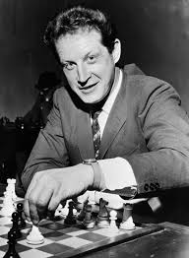
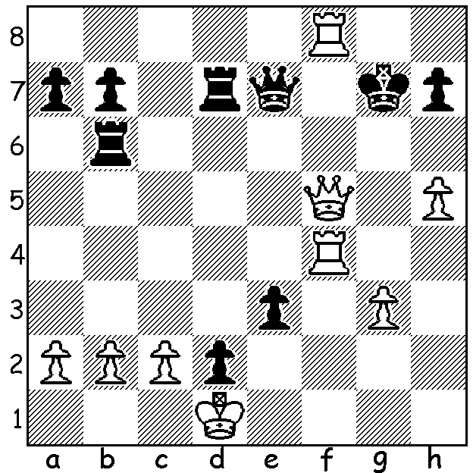

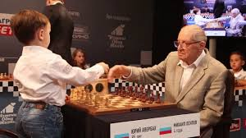

Yuri Averbakh vs Frantisek Zita 1950:
with ...e2+ threatened every White
move must be forcing, mating in 6:

Averbakh in earlier times and at 95
playing 4 year old Misha Osipov.

GRANDMASTER NOW 100
Last week Russian Yuri Averbakh became the first Grandmaster to reach one hundred years and, despite his eyesight and hearing having declined, has continued to devote time to chess related activities. Born 8th February 1922 to a German Jewish father and a Russian mother, he went with his parents to live in Moscow when he was three. His first major success was first place in the strong Moscow championship in 1949. He became a GM in 1952, won the USSR championship in 1954 and qualified for the 1953 Candidates (to find a challenger to the world champion). His style was characterised as very solid and difficult for attacking players to overcome, often leading them to losses in over pressing. He has been a prolific writer most notably in endgame theory and studies, besides contributing to opening theory, especially the Kings Indian Defence (ie Averbakh Variation).

The PERTH OPEN with 41 entrants was played at N Woodvale last weekend with Grandmaster Temur Kubokarov competing in WA for the first time. Although he scored 6/6 he was certainly made to work for his score. Second were Patrick Gong and Rebo Fu with 5/6. Other major prizes: Under 2150 Oscar Gao (4.5/6), Under 1850 Josh Davoll, Gyula Plaganyi, Ned Tomic, Herbert Cadag (all 4/6), Under 1550 Alex Pimenov (4/6), Under 1250 Naveen Umasankar, Daryoush Darani (both 3/6). The next WA Grand Prix event will be the Summer Rapid on 27th February.

SOLUTION: 1.Rg4+ Rg6 2.h6+! Kxh6 3.Rxg6+ hxg6+ 4.Qh3+ Kg5 5.Qh4# or 4...Kg7 Qh8# or 4...Qh4 5.Qxh4+ Kg7 6.Qh8#

