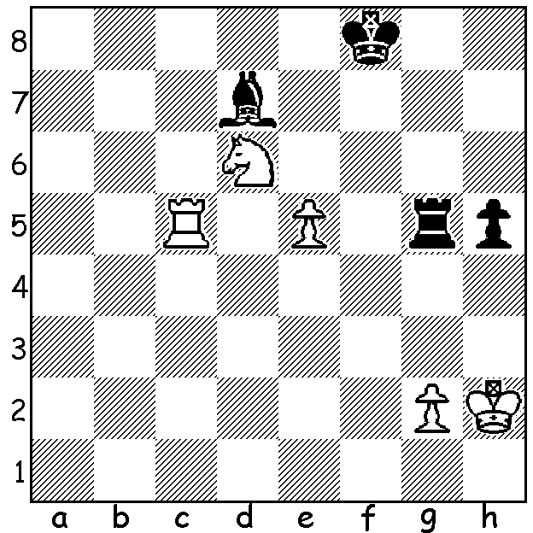

Temur Kubokarov vs Patrick Gong,
the decisive game in last week’s
Perth Open.
White to play and win.

NAKAMURA’S EXPLOSIVE RETURN TO CLASSIC CHESS
American GM Hikaru Nakamura’s last classical game had been in November 2019. Since then he had concentrated his energies on online chess which included setting up his own sites - his Twitch channel reaching a million followers. He was offered a wild card to play in the 2022 Grand Prix despite criticism that an inactive player should not be invited. The first leg was played this month in Berlin after the German capital was chosen by the vote of the of the public – a worthy choice with 23% of its population playing chess over the board and/or online. The entrants were placed in four groups of four, playing each other twice before the four winners went into the knockout stage. The semis, with three Americans, pitted Nakamura against Hungarian Richard Rapport with Nakamura winning 1.5-0.5 while Levon Aronian overcame Leinier Dominquez by a similar score. In the final, after two draws Nakamura was in his element, winning both rapid play deciding games.
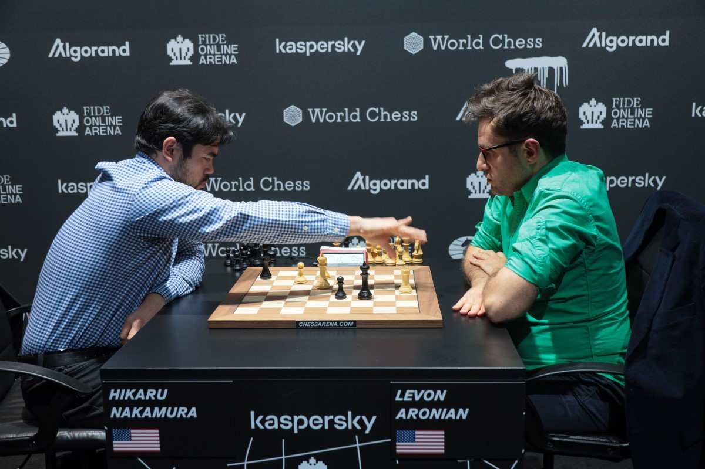
The SUMMER RAPID WA (Grand Prix event)
will take place tomorrow at N Woodvale Primary, starting at 10.30. See cawa.org.au for details or contact Dylan Gough 0402 747 737.

SOLUTION: 1.e6!! If 1...Rxc5 2.exd7 Ke2
3.e8=Q+! Kxe8. 4.Nb7+ / 5.Nxc5. However
Black played the resourceful 1...Rg6 but after
2.exd7 Rxd6 White wins with 3.Rc8+ Ke7
4.d8=Q+ Rxd8 5.Rxd8! Kxd8. Real Grandmaster play! The White king will win the h pawn and escort his last pawn to g8. Thanks to Dylan for providing me with the position.
Nakamura winning first rapid play
game against Aronian

