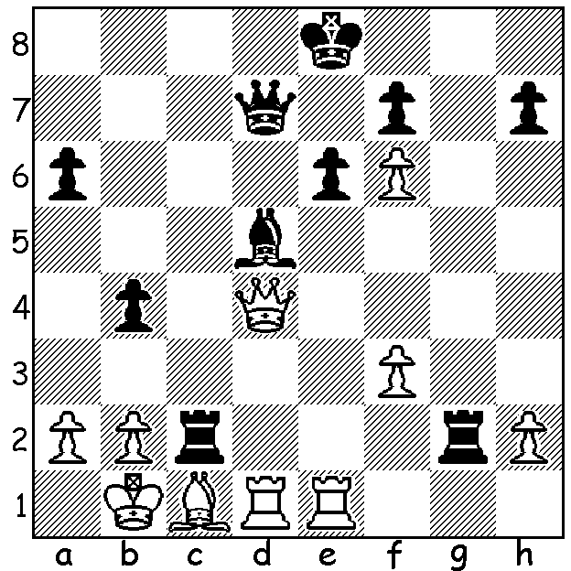
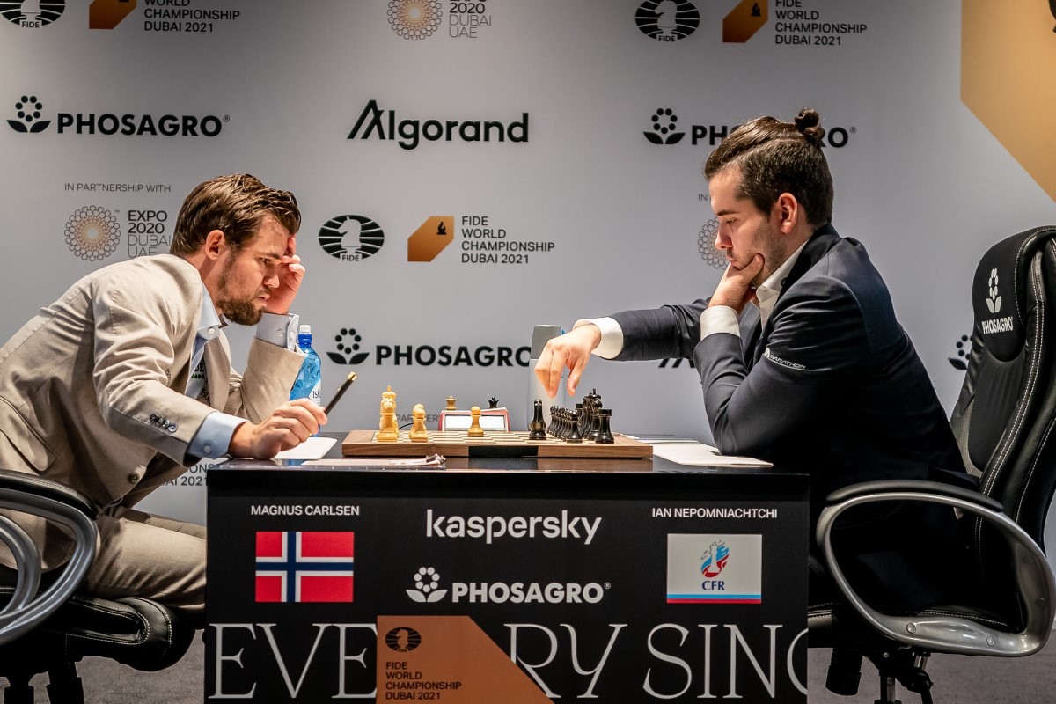
Ian Nepomniachtchi Magnus vs Nepo (from World
vs Magnus Carlsen Championship)
(Airthings Masters Finals 2022)
Black to play and win.

MAGNUS DEFEATS NEPO IN RAPID FINALS
The Airthings Masters, the first of nine legs of the Champions Tour, was held late last month with 16 competitors playing online Rapid (15min + 10sec). The field was a mix of well-established players and some up-and-coming stars. After a round robin the top eight went into a knock-out. Ian Nepomniachtchi was the convincing winner of the round robin with world champion Magnus Carlsen second. Magnus had a poor start losing four games in the first two days including to Nepo and sixteen year old Indian Rameshbabu Praggnanandhaa before recovering well on Day 3. The final of eight games saw the two world championship rivals, Magnus and Nepo, again locking horns. An exciting contest resulted in five hard fought draws before an elementary blunder in Game 6 handed the game to Magnus who then won Game 7 (see position) to win the tournament. Besides Pragg other younger players included finalists Andrey Esipenko (Russia, 19) and Vincent Kramer (Germany, 17) while established players Anish Giri (Netherlands) and Levon Aronian (now USA) failed to make the finals.

WA ALLEGRO CHAMPIONSHIPS Sunday March 13. See cawa.org.au

SOLUTION: 1...Rxc1+! (not 1...Qa5?? 2.Qxd5) 2.Kxc1 (2.Rxc1 Bxa2+ wins queen) 2...Qc6+ 3.Kb1 Qa4 4.Rd2 Bxa2+ White resigns (5.Kc1 Qc6+ 6.Kd1 Bb3+ or 5.Ka1 Bb6+ 6.Kb1 Qa2+ 7.Kc1 Qa1#).

