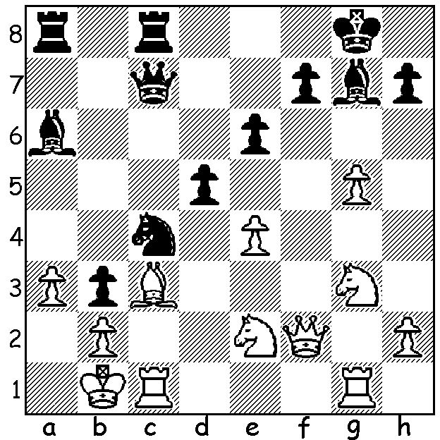
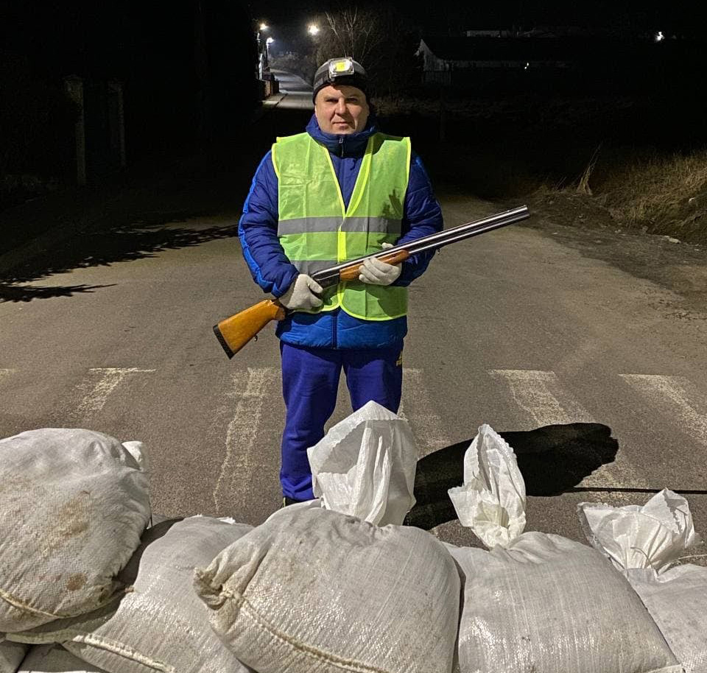

Marie Sebag vs
Olexsandra Sulypa 2004: Sulypa armed and
Black to play and win: ready to defend Ukraine

FIDE’S REACTION TO RUSSIAN INVASION
The world governing body of Chess, FIDE (Federation Internationale des Echecs), has taken a number of actions against Russia following the attack on Ukraine. It announced that ‘no official FIDE tournaments and events will be held in Russia and Belarus’ which means the 2022 Chess Olympiad will not be held in Russia as scheduled (India seems to be the most likely country to host the event). It has also banned any players from Russia or Belarus from displaying their national flags at tournaments. This falls short of the Olympic Committee’s resolution to completely ban Russian sports persons. Action has been taken against three Russian individuals for expressing support for the invasion. GM Sergey Shipov and GM Sergey Karjakin, challenger for the world title in 2016 and originally from Ukraine, have both been banned and former world champion Anatoly Karpov, a member of the Russian parliament, has lost his position as an Ambassador for Chess with FIDE. In sharp contrast with the actions of his long-time rival Garry Kasparov, a long-time Putin critic, donated $10,000 in support of Ukraine from his Chess Foundation. In his interview on The 7.30 Report with Leigh Sales he said that Putin is not a chess player, he is a poker player. In general prominent players worldwide have spoken against the war and in a brave statement one of Russia’s leading players, GM Alexander Grischuk said, “I am very sad …. In my view what we are doing is very wrong from both a moral and practical view.” A number of other leading Russian GMs have banded together to send an open letter to Putin pleading for a halt to the war. On the Ukraine side, like many other sports persons, GM Oleksandra Sulypa, captain of the Ukraine Olympiad team, has made the decision to help in the defence of his country, posting a photo of himself armed.

WA ALLEGRO CHAMPIONSHIPS tomorrow, Sunday March 13. See cawa.org.au

SOLUTION: 1...Nd2+! (clearance sacrifice): if 2.Bxd2 Bd3+ 3.Ka1 Rxa3#. White played 2.Ka1 but resigned after 2...Bxe2 3.Nxe2 Qd6 (4.Bxd2 Rxa3+ 5.Kb1 Ra1+! 6.Kxa1 Qa3+ 7.Kb1 Qa2# or Qxb2#)

