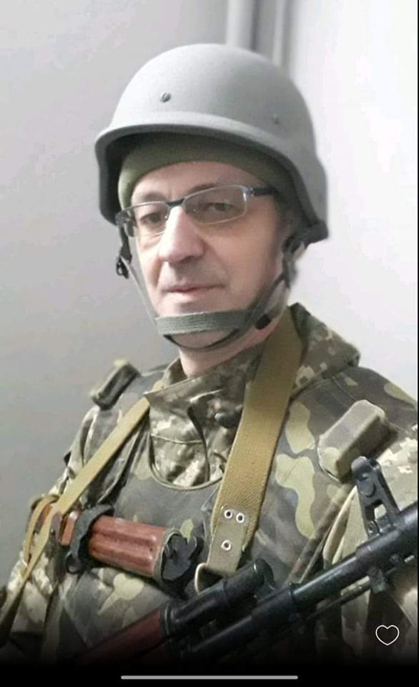
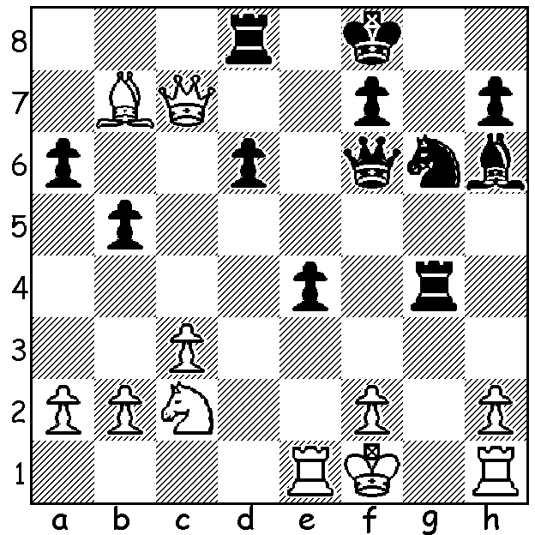

Amador Rodriguez Cespedes
vs Yuri Timoshenko, 1998
A surprise move leads to a Yuri Timoshenko
quick win for Black:

CHESS AND THE RUSSIAN INVASION
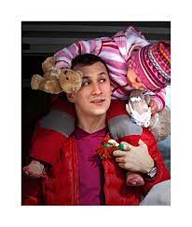
FIDE has emphatically condemned the invasion of Ukraine saying, “FIDE stands united against wars as well as condemns any use of military means to resolve political conflicts.” Nigel Short, a former challenger for the world title who played a simultaneous against 35 Perth players in 2016, is now vice president of FIDE. He stated, “The Russian invasion of Ukraine is the most appalling act of aggression against a sovereign nation.” There have been calls for the resignation of FIDE President Arkady Dvorkovich, a former Russian government minister. Last week I mentioned FIDE’s actions against Russian players who have supported Putin’s attack including former world title challenger Sergey Karjakin who had said, “I will support my country in any situation without thinking for a second.”
Many other Russian players have come out against the war and 44
of them have sent a joint letter to Putin ending with the plea ‘Stop the war!’ Other Russian players have sought to move to other affiliations, one being GM Evgeny Romanoy who has changed his
allegiance to Norway, a country he has strong links to as a coach for its national team. Among a number of Ukranian players who joined the defence of their country was Alexey Druzhinets, a children’s coach and arbiter who died of wounds suffered in action on March 2. Alexey Druzhinets

SOLUTION: 1...Qf3!! 2.Qxd8+ Kg7 3.Nd4 (if 3.Rg1 Qh3+ 4.Ke2 Qd3# or 4.Rg2 Qxg2+ 5.Ke2 Qf3+ 6.Kf1 Qh3+ 7.Ke2 Qd3#: if 3.Bxe4 Rxe4 wins ) 3...Qh3+! 4.Ke2 Qd3#). GM Yuri (Georgy) Timoshenko is one of a number of Ukrainian players to have joined in the defence of his country.

