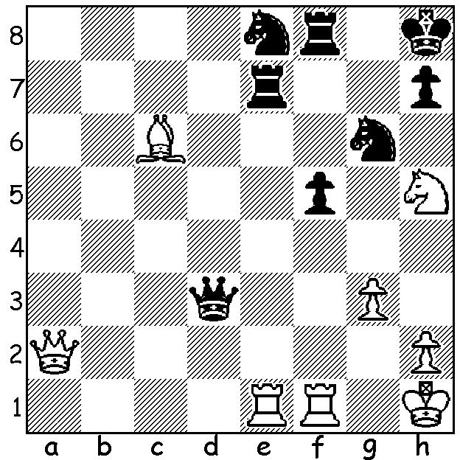
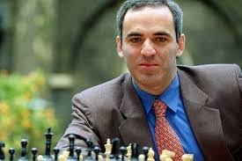
Garry Kasparov vs Iglesias Galacia 1991: White to play and win:

WINTER IS COMING
One attribute of a successful chess player is the ability to look ahead and see possible future outcomes. Former world champion Garry Kasparov undoubtedly had this ability, not only in chess but also in his analysis of the political situation in Russia. He has been a long time critic of Vladimir Putin, culminating in a failed attempt to gain nomination for the Russian presidency, a plan stymied by a regulation brought in to prevent his standing. He was arrested more than once for his opposition to the Putin regime and believes returning to Russia would result in imprisonment or death. In his book ‘Winter is Coming’, published in 2015 after the Russian annexation of Crimea,
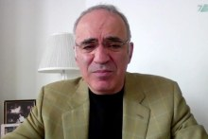
he warned against likely further Russian aggression. He claimed Putin’s Russia is an even more dangerous threat to the world than religious terrorist groups and advocated that leaders of the free world unite and put in place strong economic sanctions,
find alternatives for Russian energy exports, isolate Russia diplomatically and give economic and military support to its likely targets. Such recommendations are only now being put in place following the brutal and brazen attack on Ukraine. Not surprisingly Kasparov has become a much sought after media speaker, including an interview with Leigh Sales on ABC’s 7.30.

SOLUTION: 1.Qa1+ (important to give extra protection
to his back rank) 1...Kg8 2.Rxe7 Nxe7 3.Bxe8 and if 3...Rxe8 4.Qg7# (moves 2 & 3 ‘Destroying the Guard’ theme). Kasparov at 7.30 ABC interview

